

**FACULTY OF APPLIED INFORMATION TECHNOLOGY**

**Field of Study: Information Technology**

**Specialty: Programming**

Jash Vaidya

No. of student’s record book: 63847

***Online Business Card Generator***

Supervisor: Dr. Kateryna Yalova

**DIPLOMA THESIS AT FIRST-CYCLE STUDIES**

**Rzeszow 2023**

**Table of Contents**

**1 Introduction** 4

**2 Methodology** 5

2.1 Methodology of the Development Process 5

2.2 Methodology for Implementation 5

2.3 Model of Application Architecture 5

2.4 MVC Software Architecture and Single-Page Application 5

2.5 Methods or Techniques of UI Design 6

2.6 Method of Software Testing 6

**3. Life circle of the program** 7

3.1 Requirements Analysis: 7

3.1.1Functional Requirements 7

3.1.2 Non-Functional Requirements 7

3.2 Design 7

3.3 Web application site map 8

3.3.1 Homepage 8

3.3.2 Customer Login and creating the Business Card 12

3.3.3 Franchisee Login and Dashboard 18

3.3.4 Data storage: XAMPP SQL Database 20

3.4 PHP Source Code 23

3.4.1 PHP Source Code of Website Development and connection 23

3.4.2 PHP Source Code of Customer Login 25

3.4.3 PHP Source Code of creating a Business Card 26

3.4.4 PHP Source Code of Franchisee Login and Index 28

3.4.5 PHP Source Code of User Management 30

3.5 Implementation 31

3.5.1 Justification of Software Tools Choice 31

3.5.2 Front-end of the Website 31

3.5.3 Back-end of the Website 32

3.6 Testing: 32

3.7 Recommendation for Deployment: 32

**Conclusion** 33

**Literature** 34

6. Summary 35

List Of Figures 36

# **1 Introduction**

In the digital age, having a strong online presence is crucial for businesses across various industries. This thesis addresses the need for an easy and effective way to create business cards online. It recognizes the growing importance of digital marketing and the requirement for professionals from different fields to establish an online presence. With more businesses and individuals utilizing the internet to showcase their work, there is a demand for a user-friendly and time-saving method to design eye-catching business cards. By filling this gap, the thesis aims to provide customers with a practical and accessible tool to enhance their online branding.

The aim of this thesis is to increase the efficiency and effectiveness of professionals' marketing initiatives by developing a comprehensive online business card generator. The goal is to offer a streamlined experience that allows users to create customized business cards in about five minutes without relying on complex design technologies or hiring graphic artists. By providing users with the necessary tools to take control of their business card development, the thesis aims to empower them and enhance their advertising efforts.

Extensive research has been conducted on various aspects such as programming languages, database management, and website building. However, there is a lack of in-depth studies focusing specifically on the creation of a data management system integrated with a web-based business card generator. This knowledge gap presents an opportunity to leverage the strengths of PHP, JavaScript, HTML, CSS, and XAMPP with MySQL to develop a reliable and adaptable solution for generating business cards. By closing this gap, the thesis aims to contribute to the existing scholarship and advance the understanding of online business card creation.

The scope of this thesis encompasses the establishment of a fully functional website that enables users to input their information, customize the appearance of their business cards, and generate high-quality printed files. Additionally, a database management system will be implemented to efficiently store and retrieve user and client data. To facilitate prompt and transparent interaction between users and potential customers, the thesis includes the incorporation of a WhatsApp communication tool. By integrating these elements, the thesis seeks to provide a comprehensive solution that caters to the needs of professionals across various domains. The ultimate goal is to enhance the efficiency and efficacy of professionals' marketing efforts by offering a useful method for creating business cards online.

# **2 Methodology**

The method utilized for software development improves the process's organization, efficiency, and effectiveness in achieving its goals. It offers a framework for breaking the project down into manageable segments, specifying clear objectives, and outlining roles and responsibilities. The methodology supports the development lifecycle in addition to risk reduction, resource management, and quality maintenance. In the situation of the online business card maker, the methodology would require implementing a specific plan, such as Agile, to guide the development process. The strategy provides a well-organized structure for the development team to follow, ensuring that the project progresses smoothly and meets its objectives.[1]

## 2.1 Methodology of the Development Process

The method utilized for software development improves the process's organization, efficiency, and effectiveness to accomplish its goals. It offers a framework for breaking the project down into manageable segments, specifying clear objectives, and outlining roles and responsibilities. The methodology supports the development lifecycle as well as to risk reduction, resource management, and quality maintenance. In the situation of the online business card maker, the methodology would require implementing a specific plan, such as Agile, to guide the development process.[2] The strategy offers a well-organized structure for the development team to follow, ensuring that the project progresses smoothly and meets its objectives.

## 2.2 Methodology for Implementation

An object-oriented implementation style is employed for the online business card maker. The structure and structuring of code into reusable objects, encasing both data and behaviour, is made possible by object-oriented programming (OOP). This strategy encourages modularity, code reuse, and simpler maintenance. The development process is made easier to understand and more scalable by being real-world phenomena as objects. Object-oriented programming offers a logical and structured manner to represent user data, database interactions, and business card components, boosting the readability and maintainability of code.

## 2.3 Model of Application Architecture

A client-server web-oriented architecture is the model of application architecture for the online business card maker. In this method, data and functionality are requested and received from the server by the client (web browser).[3] While the server-side handles request, fetches data from the database, and carries out necessary activities, the client-side is in the position of rendering the user interface and managing user interactions. A web browser and an internet connection are required for users to access the system from any device, which is the reason why the web-oriented architecture was chosen. Additionally, it makes maintaining and maintenance simpler and provides for centralized data management.

## 2.4 MVC Software Architecture and Single-Page Application

Model-View-Controller (MVC) software architecture is used by the online business card manufacturer. The program is divided into three independent parts using this architectural pattern: the Model (data and business logic), the View (user interface), and the Controller (which controls user interactions and data flow). The MVC architectural design encourages code organization, reuse, and concern separation, that improves maintainability and scalability. Additionally, it makes it simpler to test and modify a single component without affecting the others. The program is also created as a single-page application (SPA), allowing for dynamic content loading and updating on a single web page. By decreasing the number of pages reloads while providing a slicker, more responsive interface, this strategy improves the user experience.

## 2.5 Methods or Techniques of UI Design

The strategy for the user interface (UI) design of the online business card maker adheres to contemporary web design requirements, such as responsive design, easy navigation, and aesthetically pleasing aesthetics. Using responsive design, it is made possible for the user interface to effortlessly scale and adapt to various devices and screen sizes. Users can simply comprehend and operate the application thanks to intuitive navigation, resulting in a seamless and effective user experience.[4] Incorporating aesthetically pleasing elements gives the business card designs a stylish and polished appearance, boosting overall branding and user happiness.

## 2.6 Method of Software Testing

A thorough strategy is used for the software testing for the online business card maker, and both manual and automated testing techniques are used. User acceptance testing, test scenarios, and an examination of the system to look for potential problems or usability challenges are all part of manual testing. Regression testing, unit testing, and integration testing are all carried out automatically utilizing frameworks like PHPUnit and Selenium. Combining manual and automated testing guarantees complete coverage of the functional requirements identifies errors or inconsistencies and confirms the general efficacy and dependability of the system. To ensure the stability and quality of the application throughout the development process, routine testing and continuous integration techniques are employed. [5]

# **3. Life circle of the program**

## 3.1 Requirements Analysis:

It is critical to collect and document the unique needs and expectations of the users for the online business card generator during the requirements analysis phase. This entails being aware of the business card's required fields, customization possibilities, user authentication, database management, and WhatsApp connection. To make sure the system achieves the desired goals, it is also crucial to define any performance, security, or usability requirements.

### 3.1.1Functional Requirements

1. The system should allow users to create customized business cards.
2. The system should provide a user-friendly and time-saving method for designing business cards.
3. The system should offer a variety of templates and design options for users to choose from.
4. The system should allow users to input their information, such as name, contact details, and company information.
5. The system should enable users to personalize the look of their business cards by selecting fonts, colours, and layouts.
6. The system should generate high-quality printable files of the designed business cards.
7. The system should store and retrieve user and client information in a database.
8. The system should provide efficient data management capabilities, including updating and deleting user and client data.
9. The system should integrate XAMPP with MySQL to ensure reliable and secure database functionality.
10. The system should facilitate quick and seamless communication between users and potential customers through a WhatsApp communication tool.

### 3.1.2 Non-Functional Requirements

1. Usability: The system should have an intuitive and user-friendly interface to ensure ease of use for all users.
2. Performance: The system should provide a fast and responsive experience, allowing users to create business cards efficiently.
3. Reliability: The system should be stable and reliable, minimizing downtime and data loss.
4. Scalability: The system should be able to handle a large number of users and store a significant amount of data without performance degradation.
5. Security: The system should implement appropriate security measures to protect user and client data from unauthorized access or breaches.
6. Compatibility: The system should be compatible with different web browsers and operating systems.
7. Maintainability: The system should be designed in a modular and maintainable manner to facilitate future updates and enhancements.
8. Accessibility: The system should comply with accessibility standards to ensure usability for individuals with disabilities.
9. Performance: The system should generate business card files quickly, minimizing processing time.
10. Documentation: The system should have comprehensive and up-to-date documentation to assist users in using and maintaining the system effectively.

## 3.2 Design

The system architecture and user interface are planned during the design phase. This involves developing the user interface for the business card personalization process, creating a database schema that holds user and customer information, and figuring out how data flows and interactions occur within the system.[6]To improve the user experience, the design should be simple, easy to use, and visually appealing.

## 3.3 Web application site map

### 3.3.1 Homepage

Here are the pictures of the Index (Homepage) of the website. Figure 1 shows the homepage of the Website.

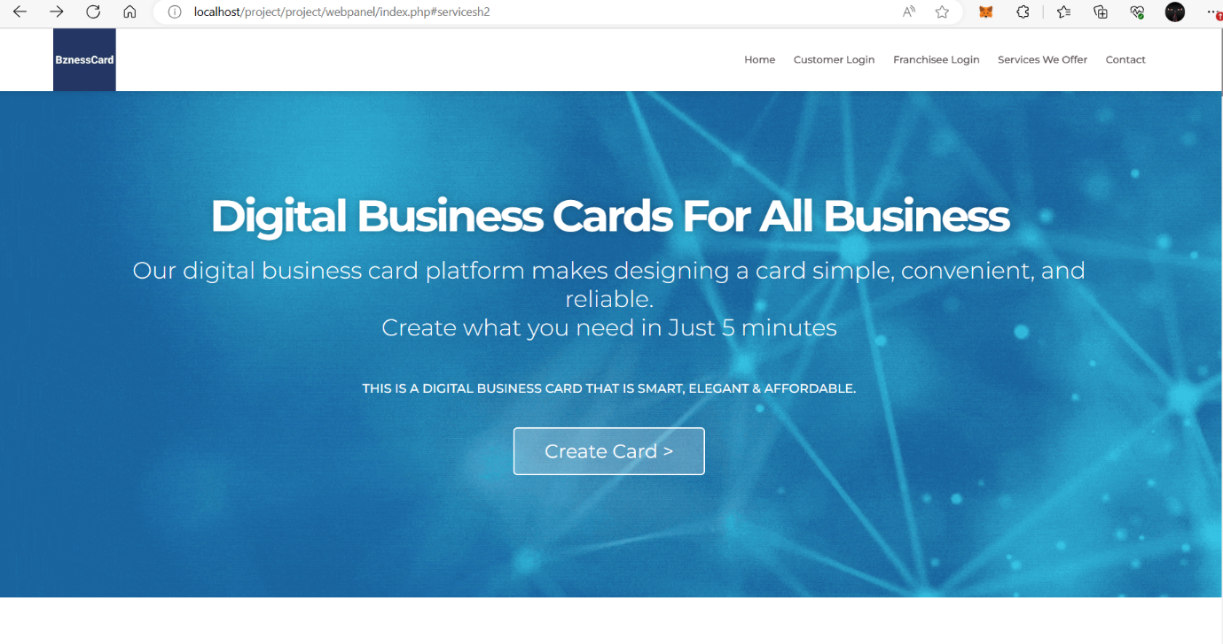

Fig. 1. Home page

Source: Own Study

When customer or admin enters the website, they will first see this page. From this page customers and Admin can login and check the services we offer. And if not satisfied or in need customer can contact the Administrator. Figure 2 shows the About Us Page.

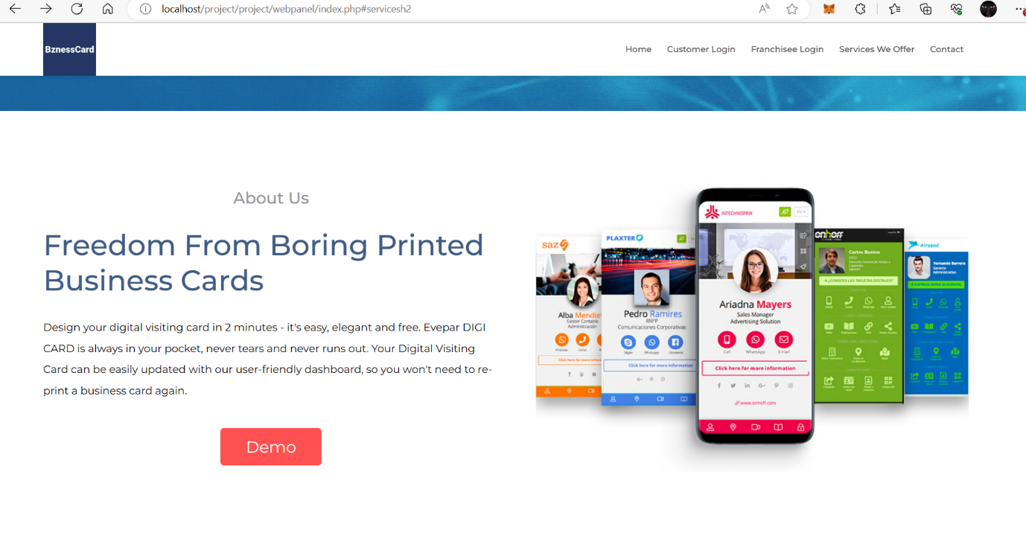

Fig. 2. About Us Page

Source: Own Stud

On how it works page Customer will see how to make cards and how Customer can download it or share it.

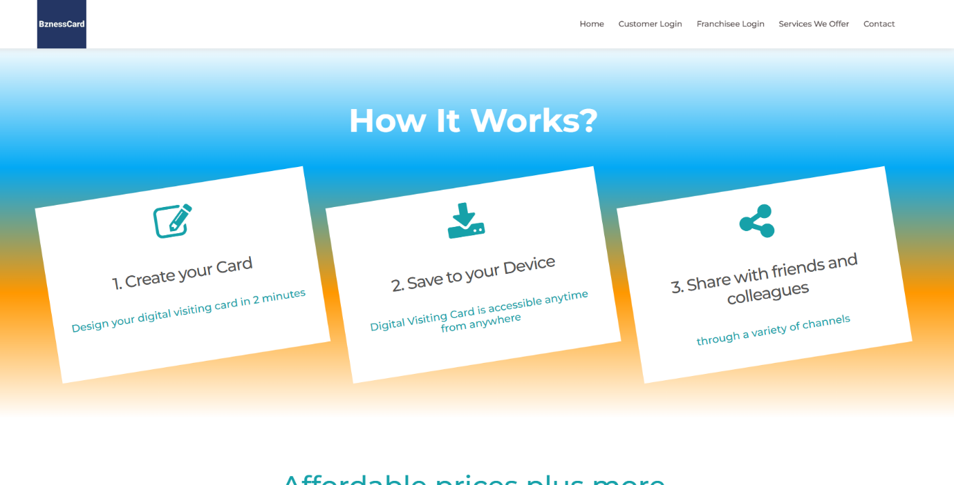

Fig. 3. How it works Page

Source: Own Study

Template selection page shows the Templates which Customer can use to create the Business card.

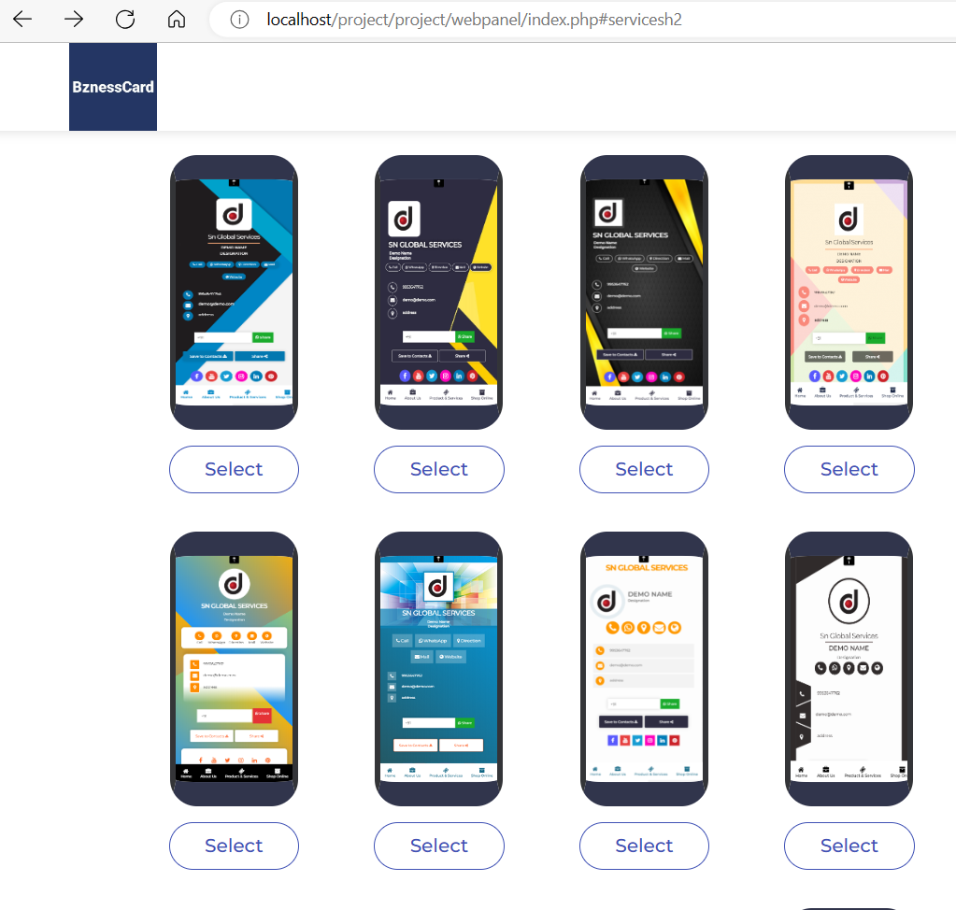

Fig. 4 Template Selection Page 1

Source: Own Study

Template selection page shows the Templates which Customer can use to create the Business card.

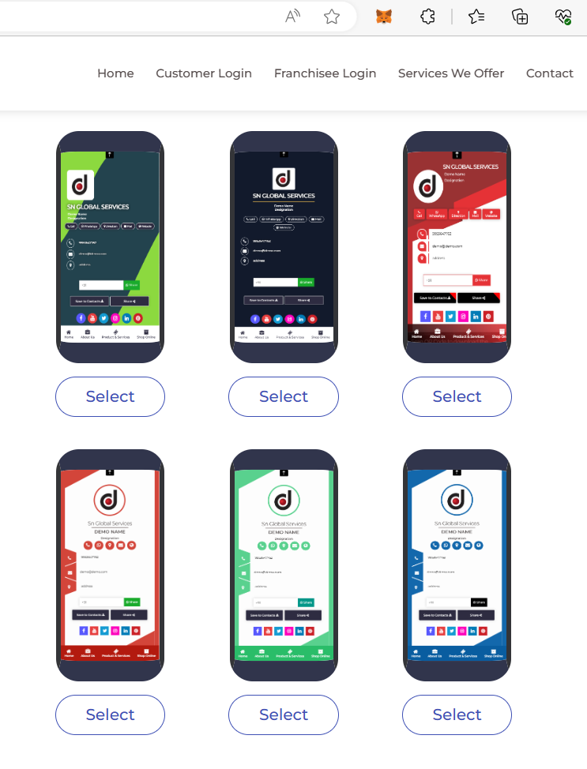

Fig. 5 Template Selection Page 2

Source: Own Study

Services we offer page shows the services we offer where Customers can check what they can do on this website and can see what the benefits of the card are.

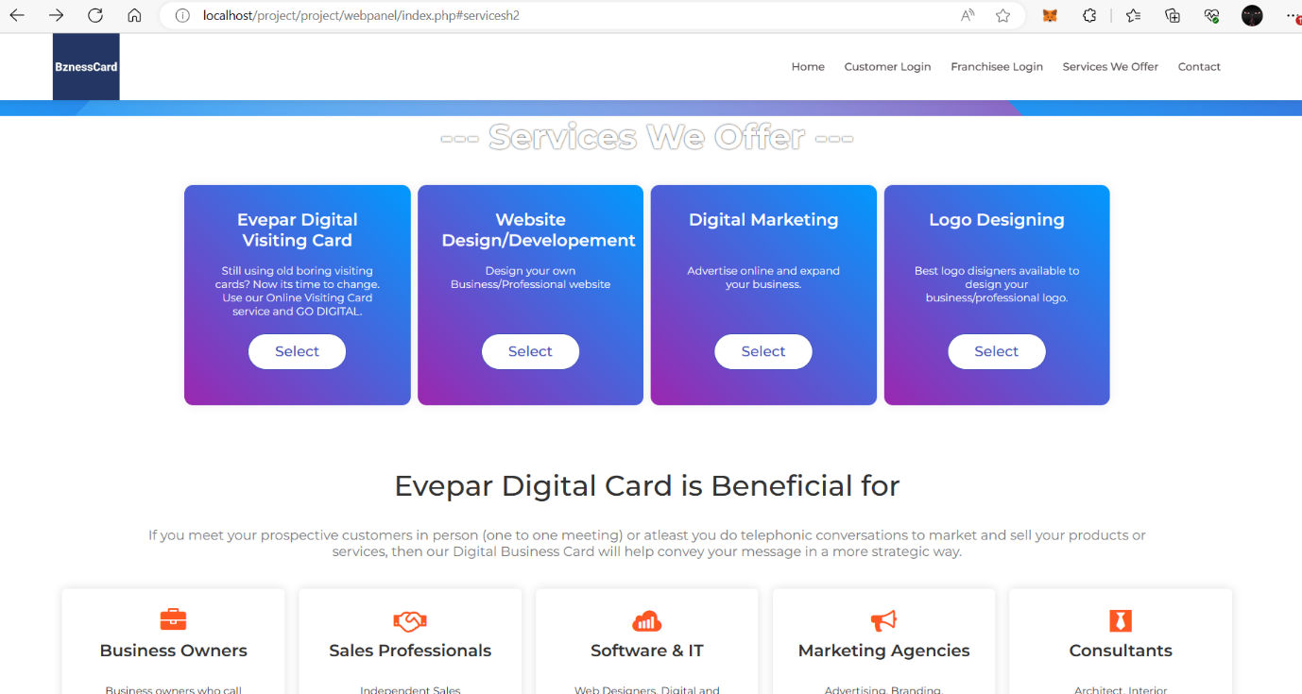

Fig. 6 Services We Offer Page

Source: Own Study

Features Page shows the Features and benefits to use this website.

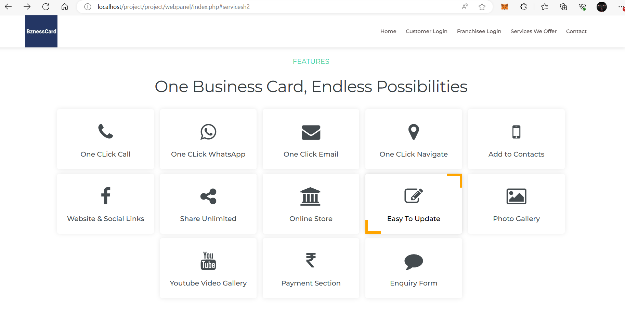

Fig. 7 Features Page

Source: Own Study

Contact us page shows the contact details of the Administrator and shows where Customer can contact us if they have any questions and Administrator can contact back to the Customer afterwards.

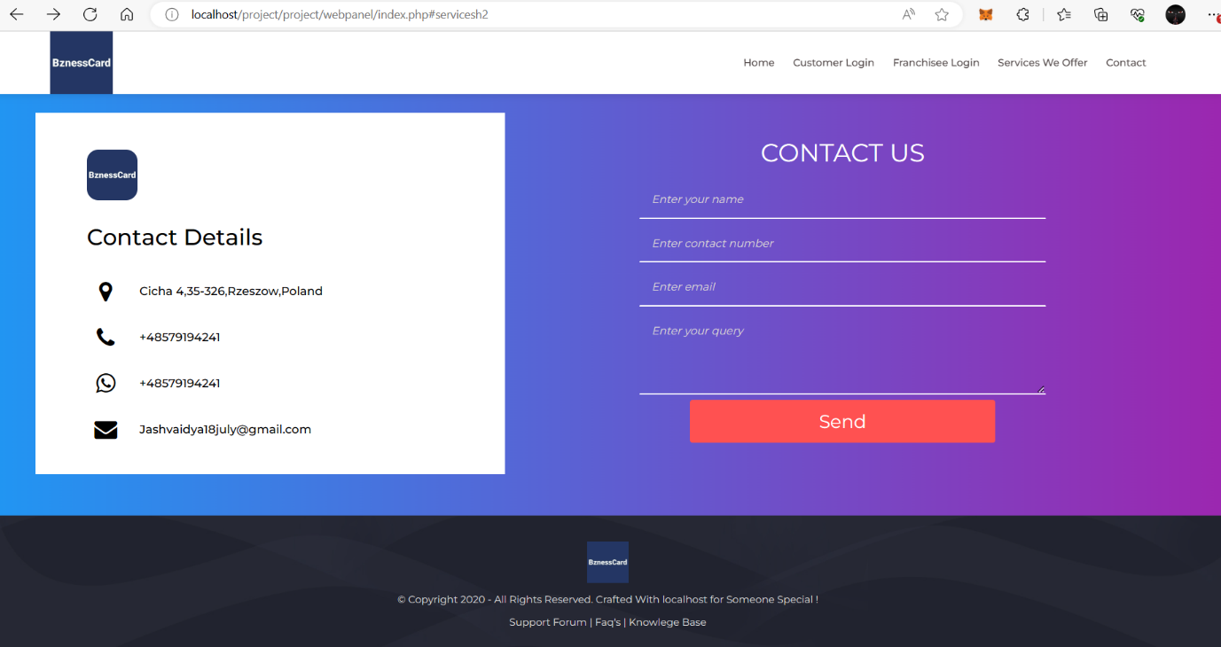

Fig. 8 Contact Us Page

Source: Own Study

### 3.3.2 Customer Login and creating the Business Card

Customer Login Page shows how customer can log in to the website. And if need they can Change or edit the password.

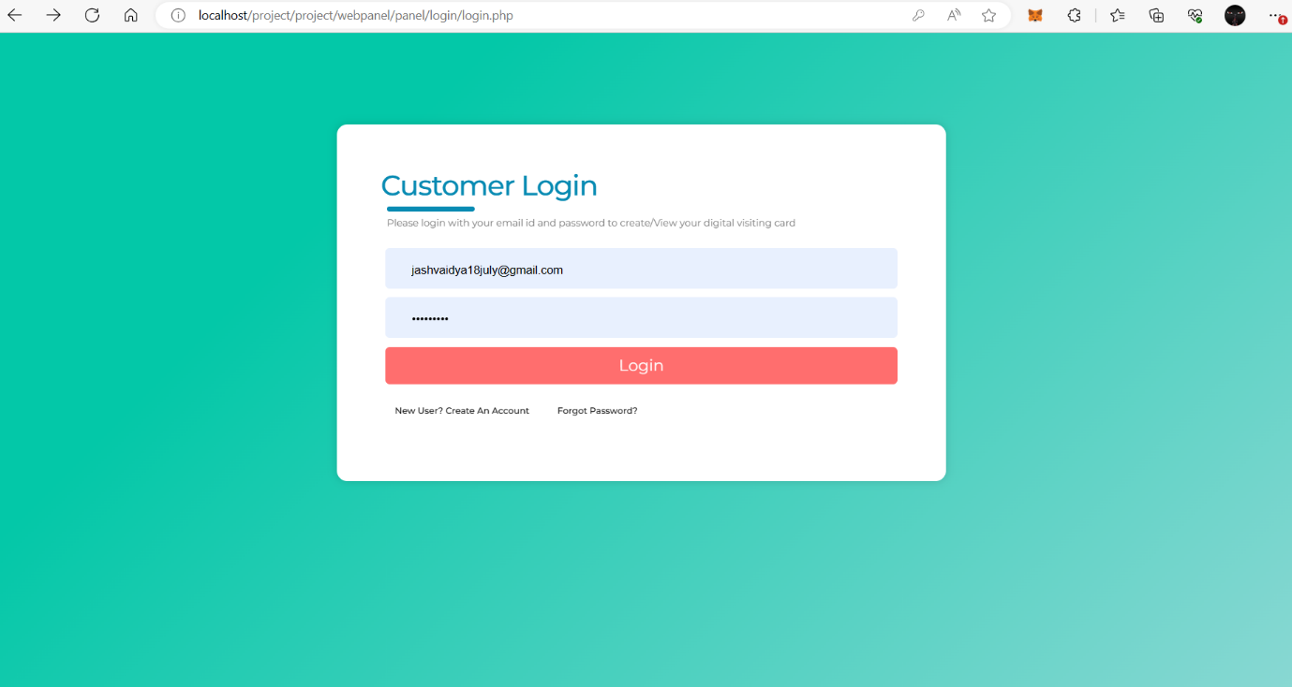

Fig. 9 Customer Log in Page.

Source: Own Study

Dashboard of Customer page shows the Dashboard of Customer Page. After customer logs in to his account he will be redirected to this page and can see and edit his order and if everything is correct, he can directly go to payment page by clicking Pay Now button.

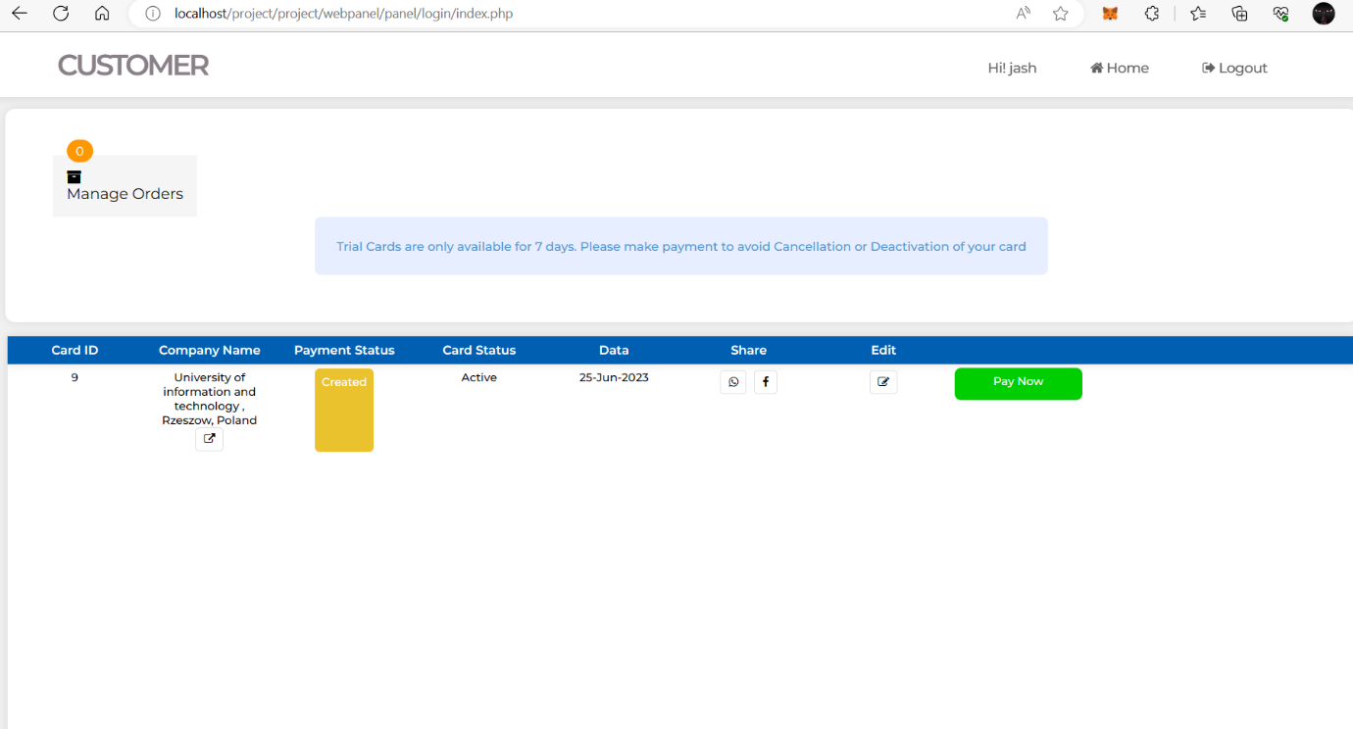

Fig. 10 Dashboard of Customer Page.

Source: Own Study

When customers click on edit card or start making new card, this is the first page they will be redirected to. On this page Customers input Business or Company Name for their Digital Card.

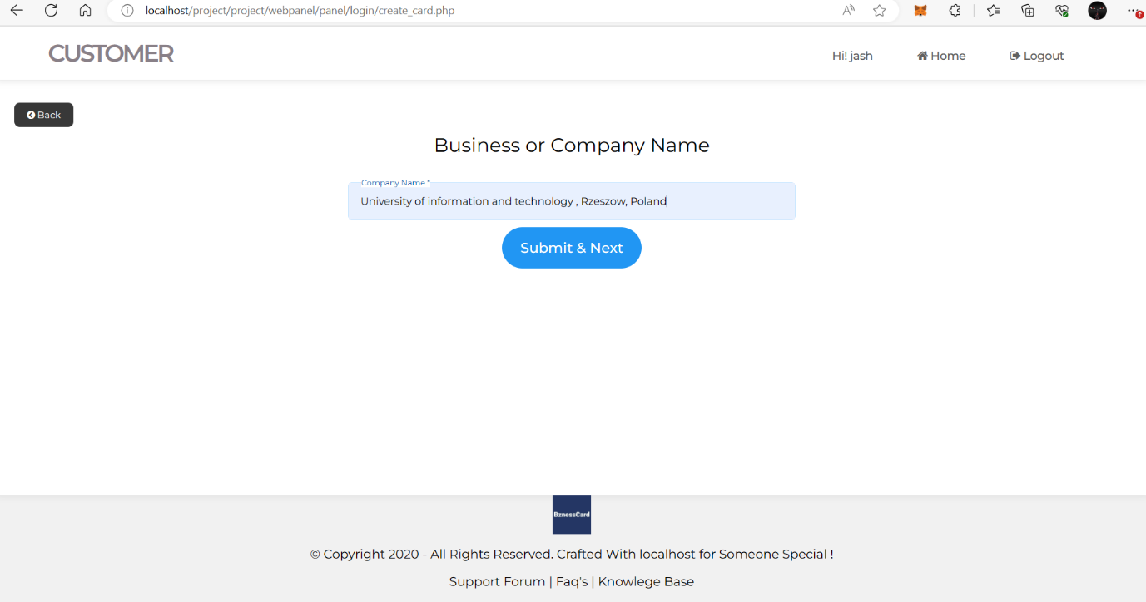

Fig. 11 Input Page for Business or Company Name.

Source: Own Study

When customers input their Business or Company Name, they can select template for their Company card as shown.

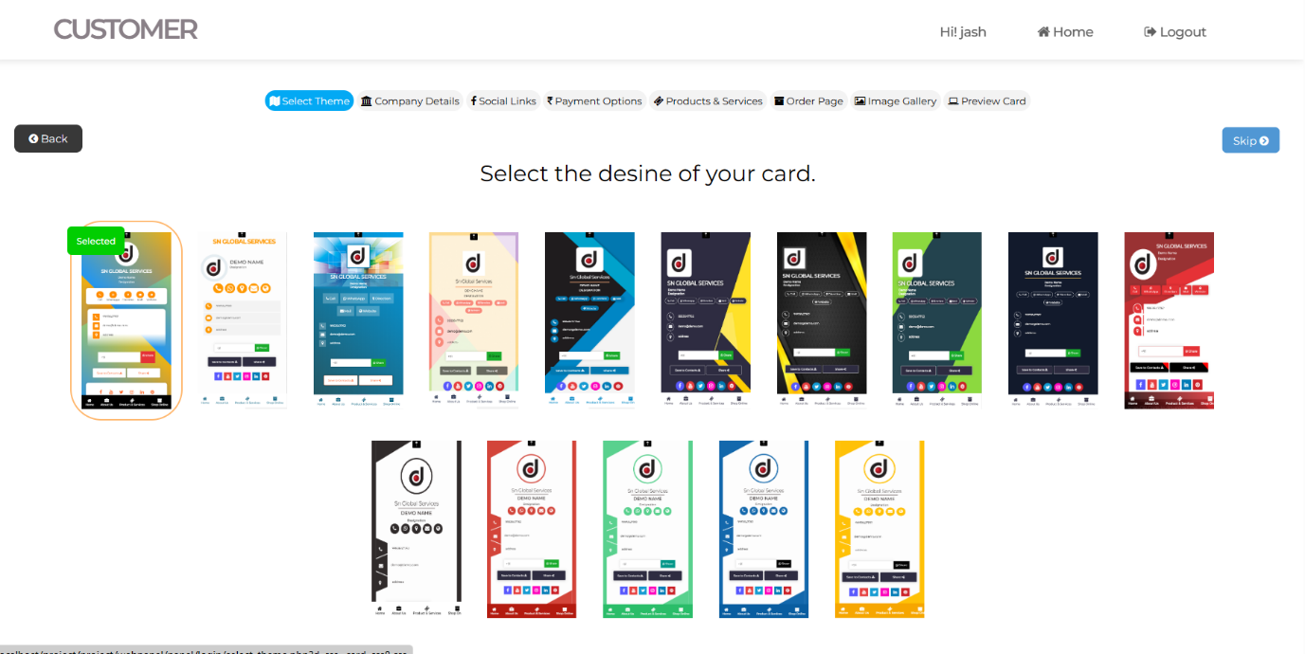

Fig. 12 Template selection Page.

Source: Own Study

After Customers will select their template, Thay can input the information like persona details and put logo for their company as shown.

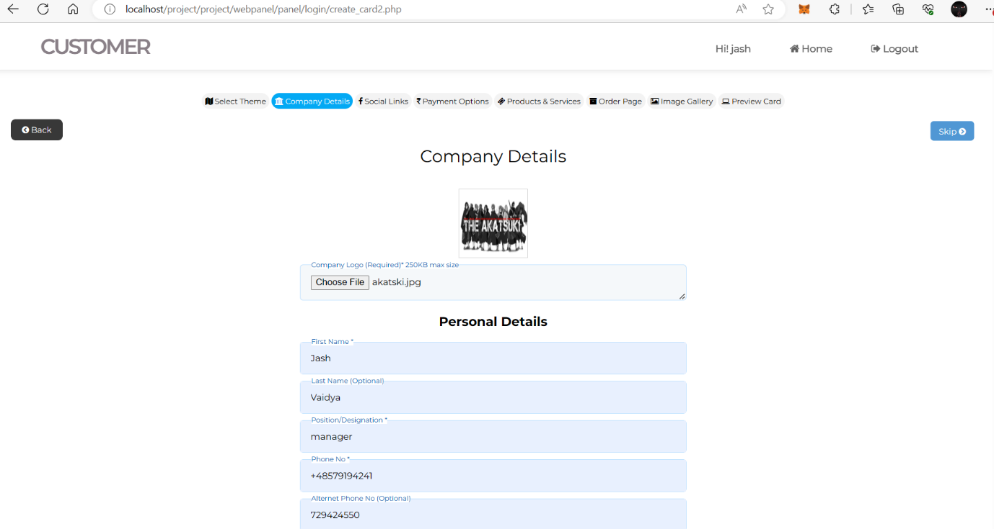

Fig. 13 Company Details Page.

Source: Own Study

After filling the information on social link page Customer can put the Social Media links like Facebook, Instagram, WhatsApp, Ect.

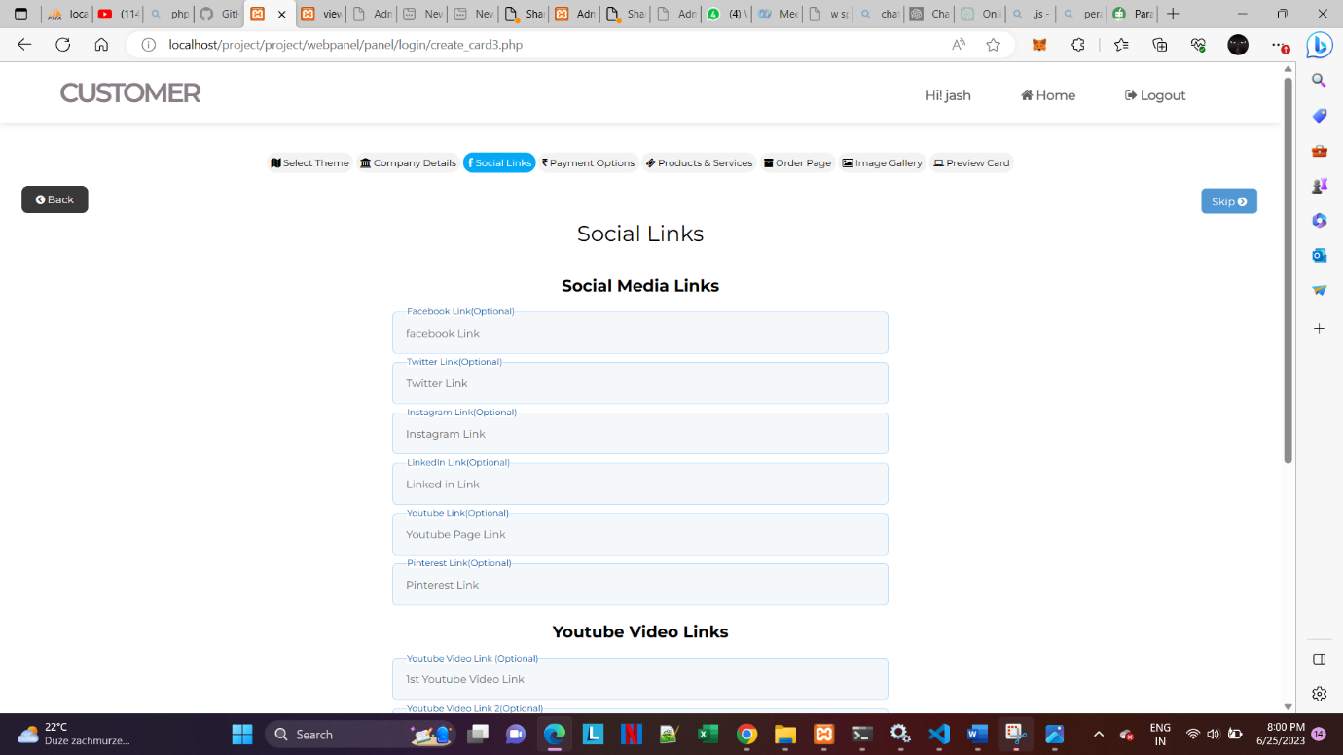

Fig. 14 Social links Page.

Source: Own Study

Customers can select the payment options and Bank Account details for their own Customers on payment options page.

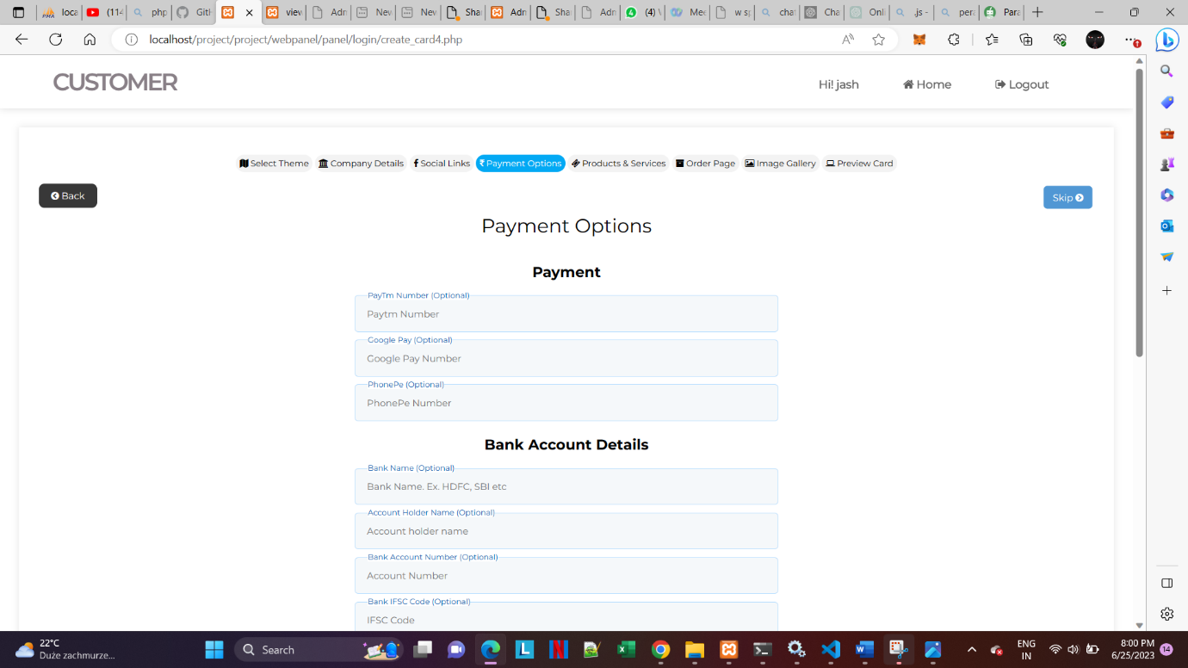

Fig. 15 Payment links Page.

Source: Own Study

Customers can Upload picture of Product or Services they will provide to their own Customers on product and service page.

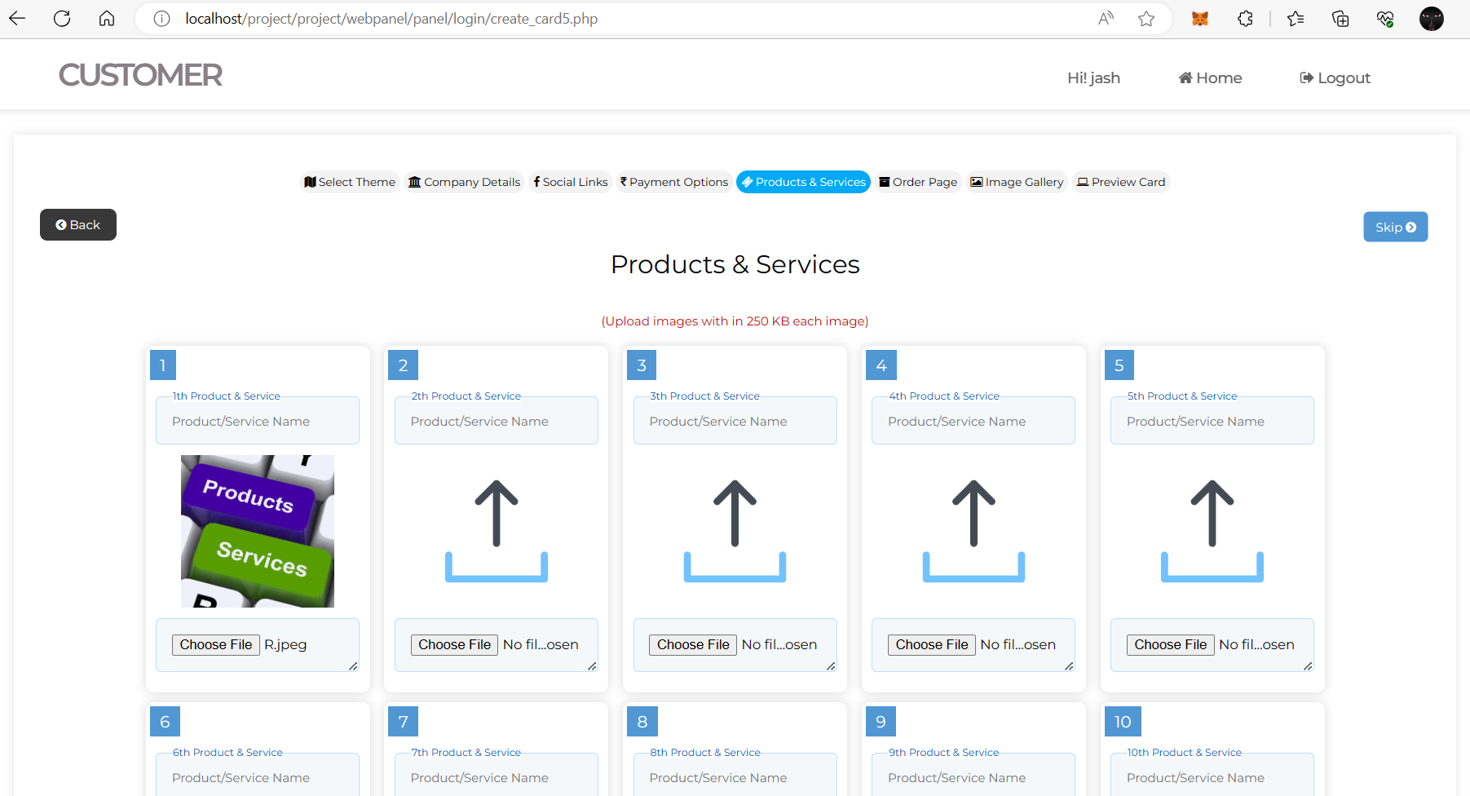

Fig. 16 Product or Services Page.

Source: Own Study

Customers can Upload picture of Product or Services they will provide to their own Customers with details on Ecommerce page.

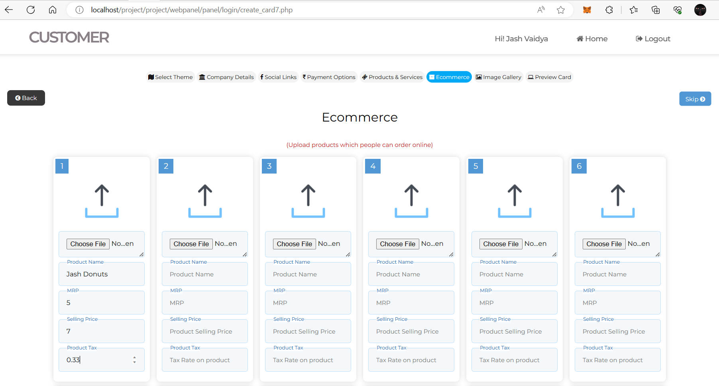

Fig. 17 Ecommerce Page.

Source: Own Study

Customers can Upload Any picture for their Customers on the Business Card on image gallery page .

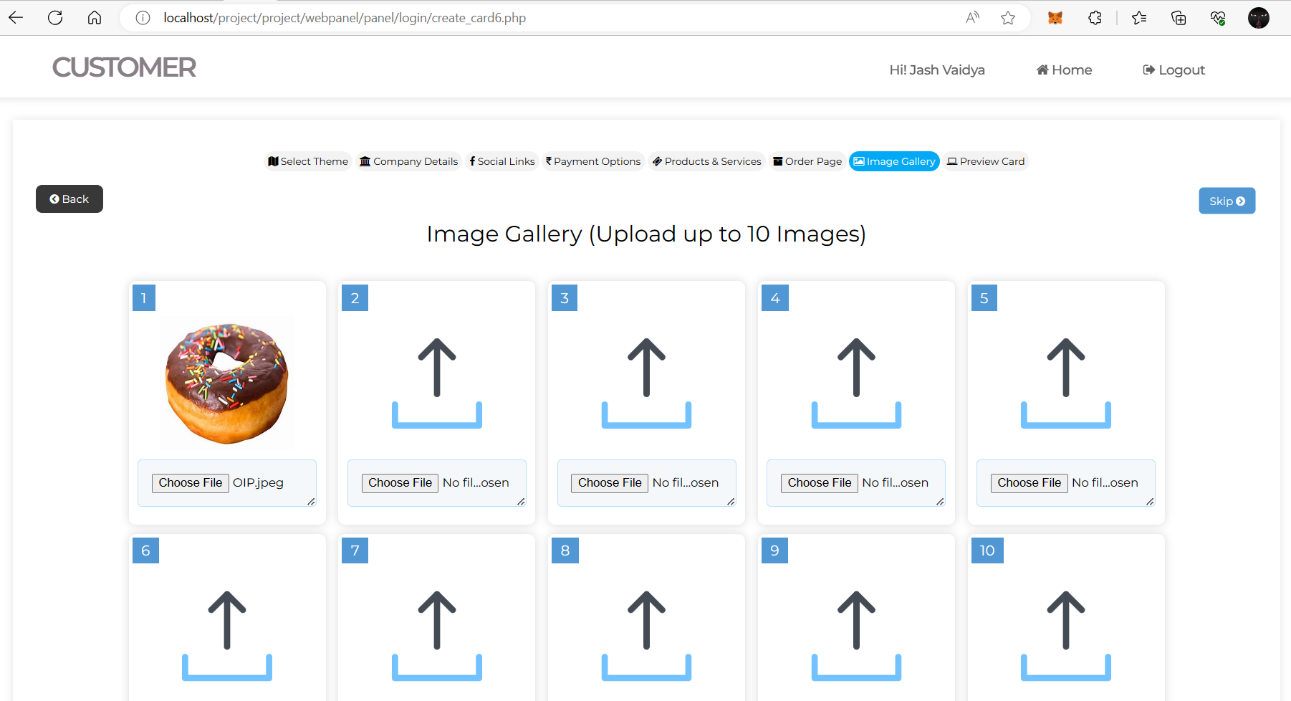

Fig. 18 Image Gallery Page.

Source: Own Study

Customers can preview their Business Card after filling all the important information on preview of business card page1.

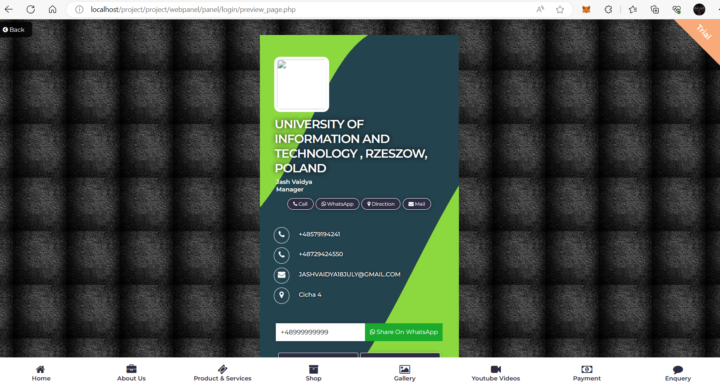

Fig. 19 Preview of Business Card Page1

Source: Own Study

Customers can preview their Business Card after filling all the important information preview of business card page2.

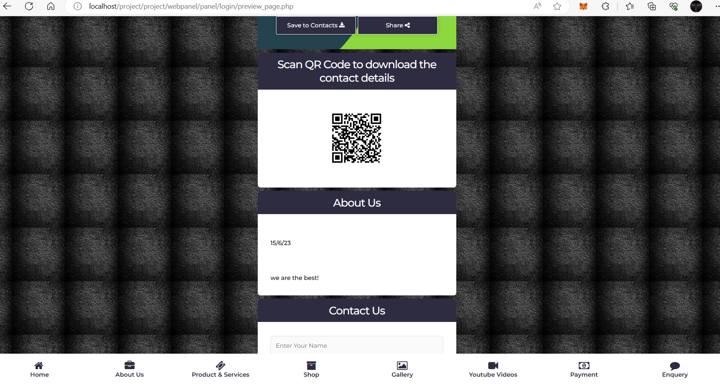

Fig. 20 Preview of Business Card Page2.

Source: Own Study

Customers can preview their Business Card after filling all the important information and there is also page for their customers to contact them on preview of business card page3.

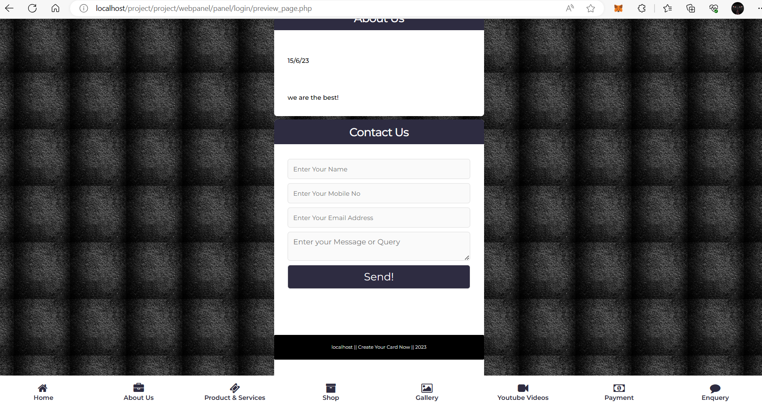

Fig. 21 Preview of Business Card Page3.

Source: Own Study

### 3.3.3 Franchisee Login and Dashboard

On franchisee login page, Business Card owners can Log in or edit their Password.

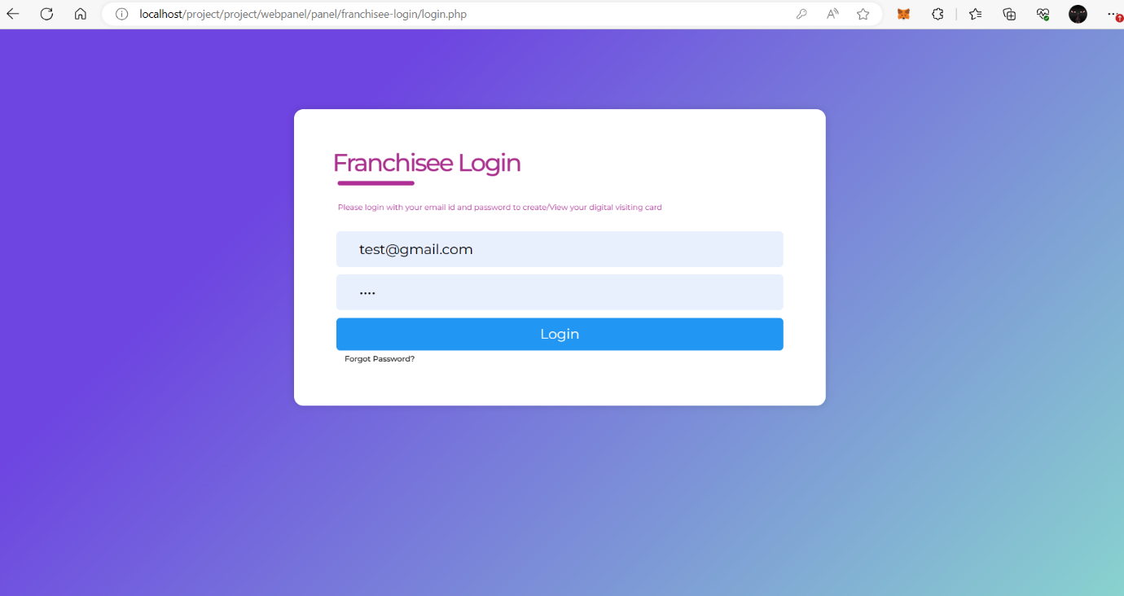

Fig. 22 Franchisee Login Page.

Source: Own Study

On Dashboard of franchisee login page, Business Card owner can manage their card details and wallet.

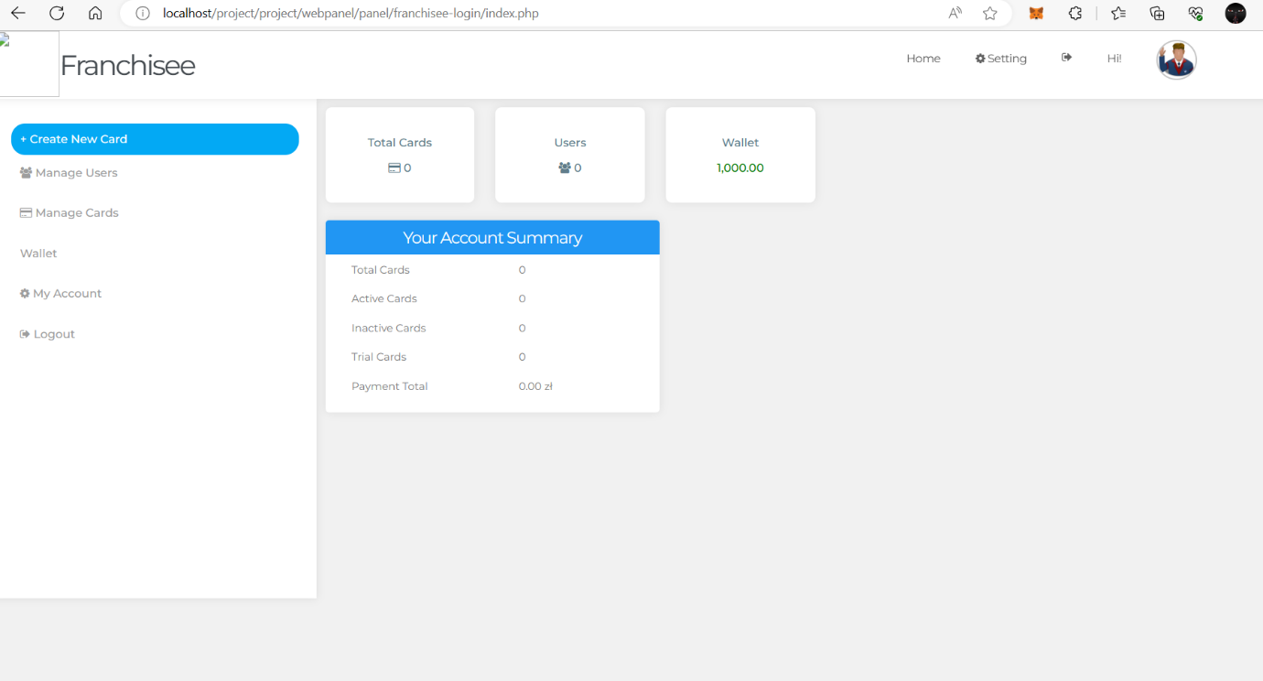

Fig. 23 Dashboard of Franchisee Login.

Source: Own Study

As shown in Add money page Customers can add Money to their Wallet.

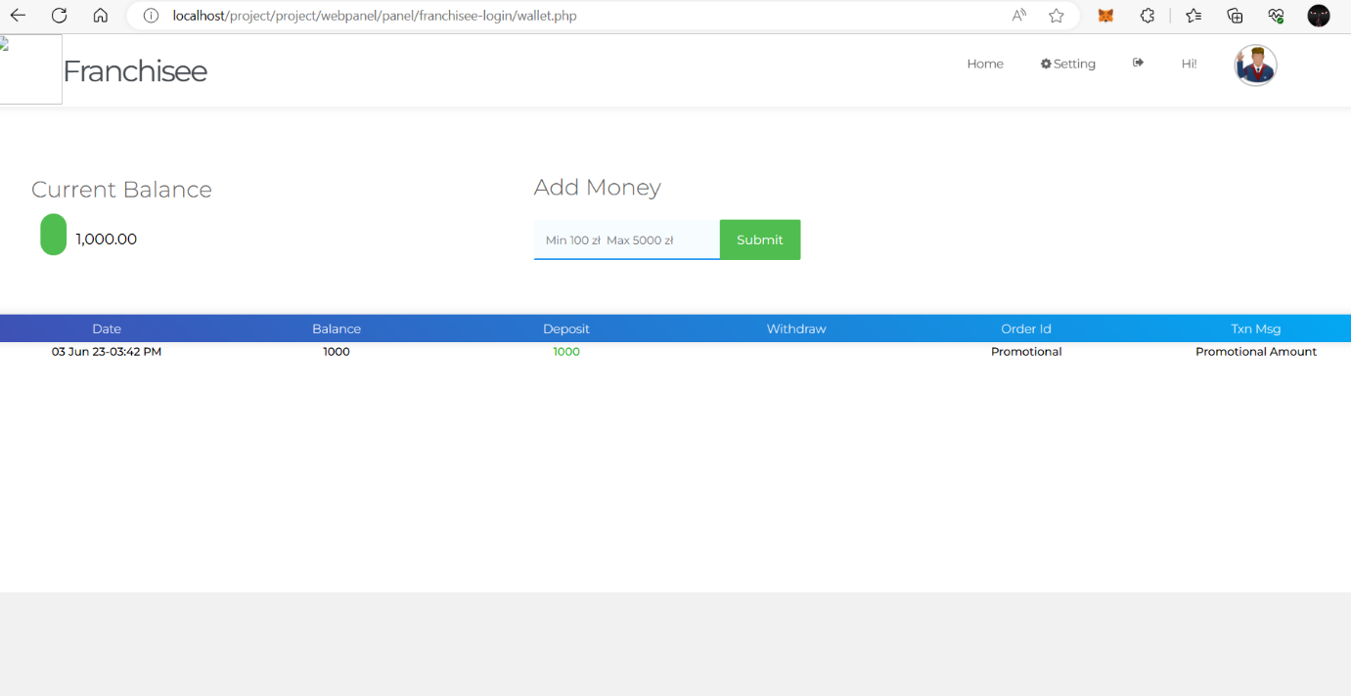

Fig. 24 Add Money Page.

Source: Own Study

As shown in franchisee profile page Customers can view or edit their Profile and the important information like Payment details, Contact details, Etc.

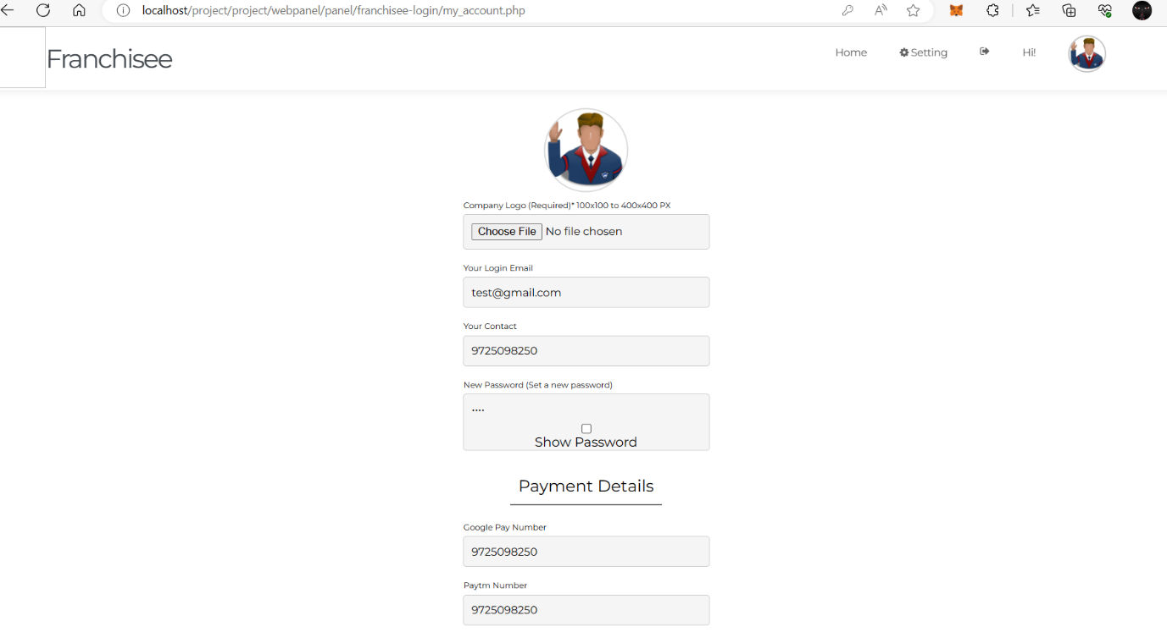

Fig. 25 Franchisee Profile Page.

Source: Own Study

### 3.3.4 Data storage: XAMPP SQL Database

SQL Database main page is the Main Page of SQL Database (PhpMyAdmin). This Page shows the total Number of tables and their names. From this page you can check and edit the tables. And you can also see or edit SQL code, query, Etc.

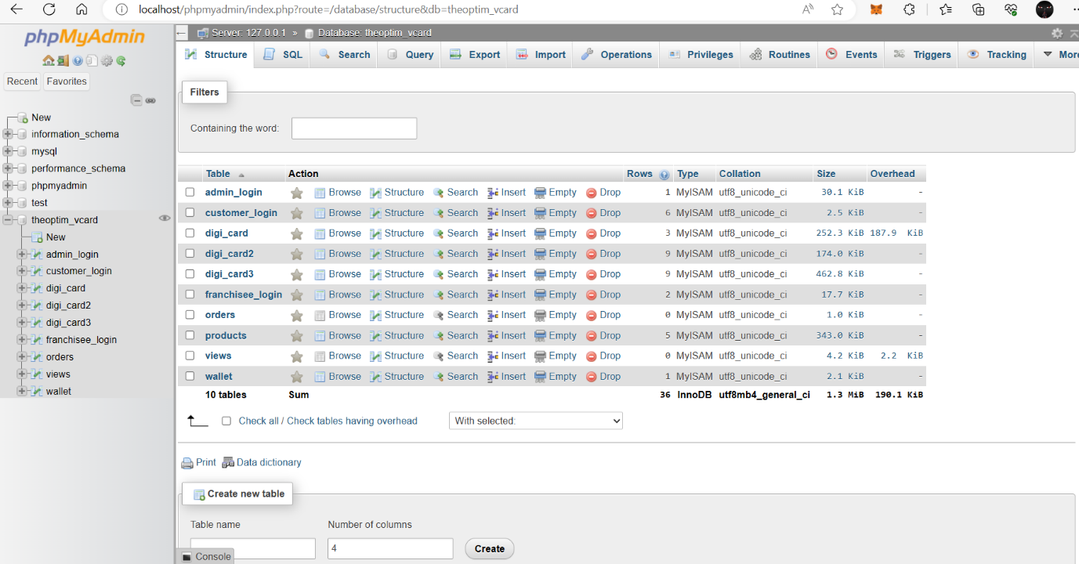

Fig. 26 SQL Database Main Page.

Source: Own Study

On SQL Database admin login table you can see the table of admin login. On this page you can add or edit admin login.

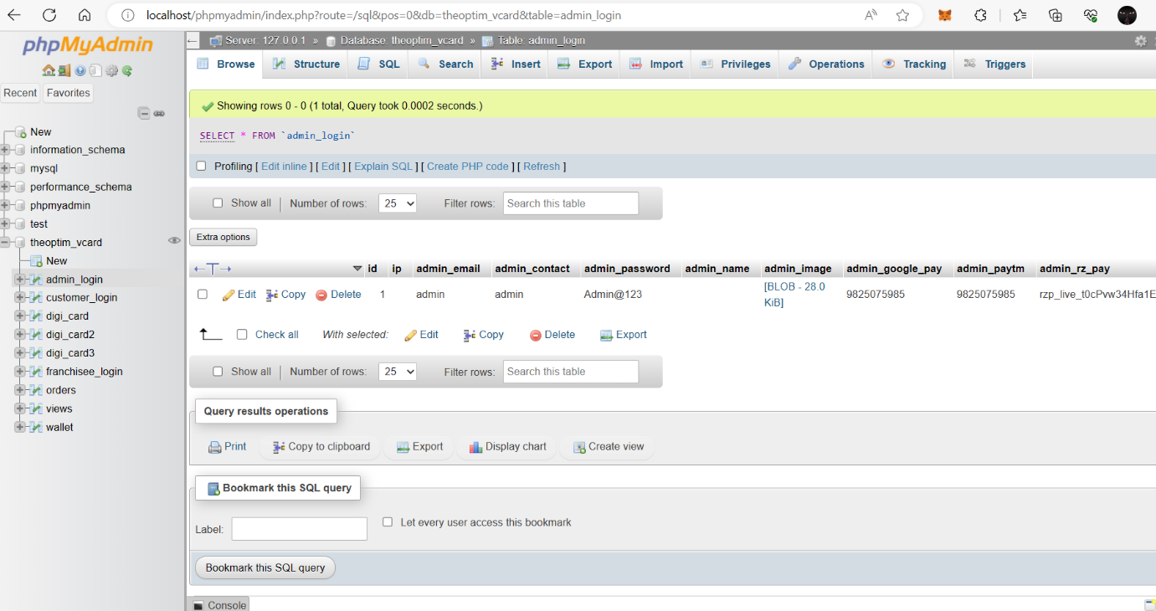

Fig. 27 SQL Database Admin Login Table.

Source: Own Study

On Database SQL customer login table, you can see the table of Customer login. On this page you can add or edit Customer login.

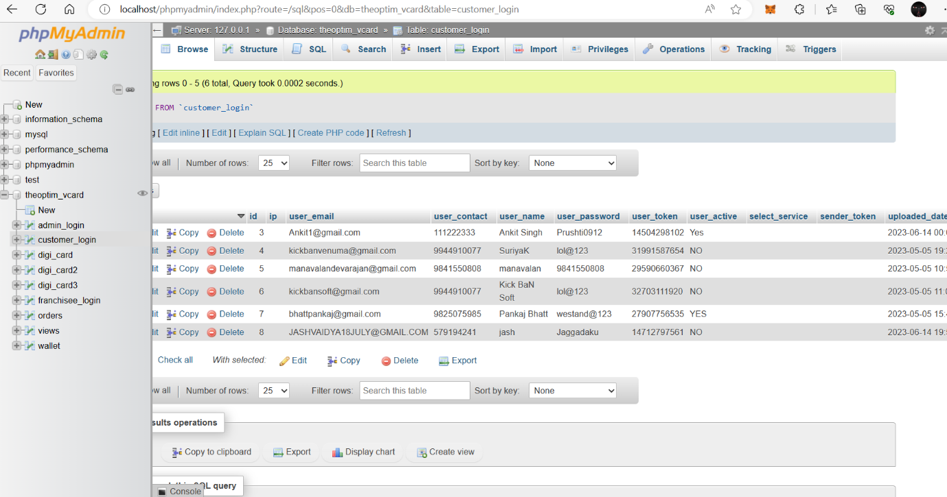

Fig. 28 SQL Database Customer Login Table.

Source: Own Study

On SQL Database franchisee you can see the table of Franchisee login. On this page you can add or edit Franchisee login.

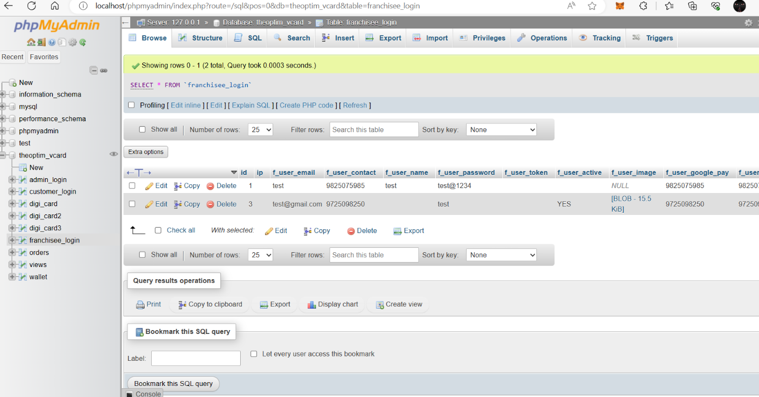

Fig. 29 SQL Database Franchisee Login Table.

Source: Own Study

On SQL Database wallet table you can see the table of Wallet. On this page you can add or edit amount in Wallet.

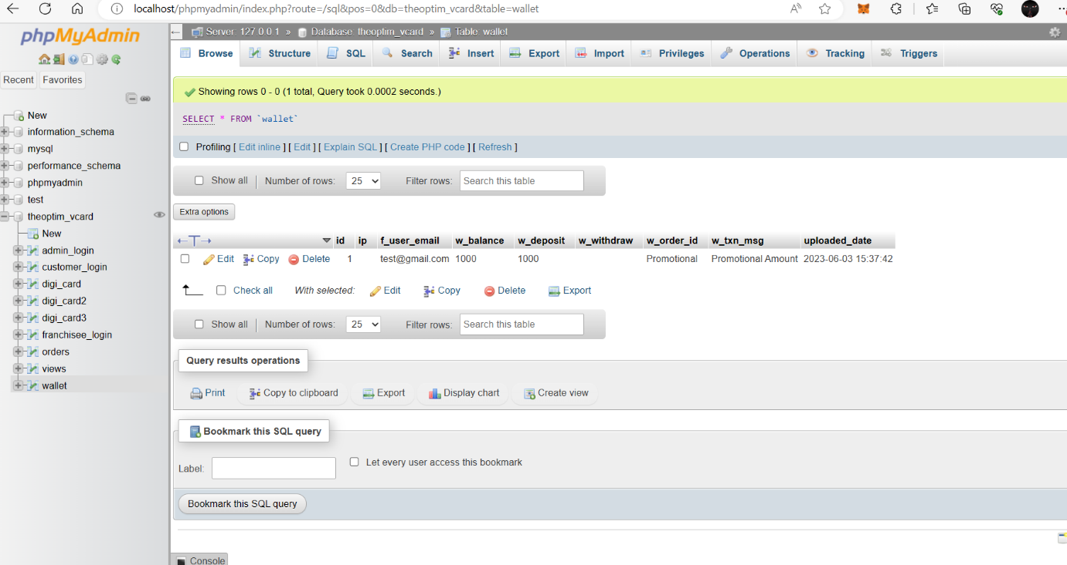

Fig. 30 SQL Database Wallet Table.

Source: Own Study

## 3.4 PHP Source Code

3.4.1 PHP Source Code of Website Development and connection

PHP Source code of the website development 1 page is the Source Code of Website Home page in this figure there is a code for main headers and buttons for the website like Contact, Home, Etc.

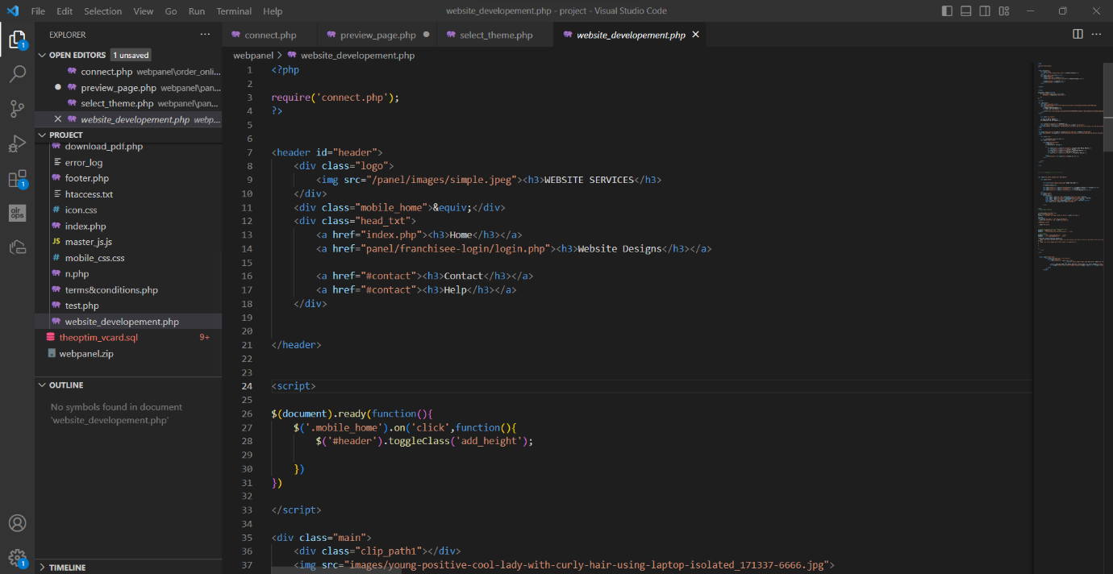

Fig. 31 PHP Source Code of Website Development (1)

Source: Own Study

PHP Source code of the website development 2 page is the Source Code of Website Home page in this figure there is a code for Contact information with Administrator’s Address, Phone Number, and email address and Interactive code for Customer to Contact with their Name, Phone Number, Email, and their Questions.

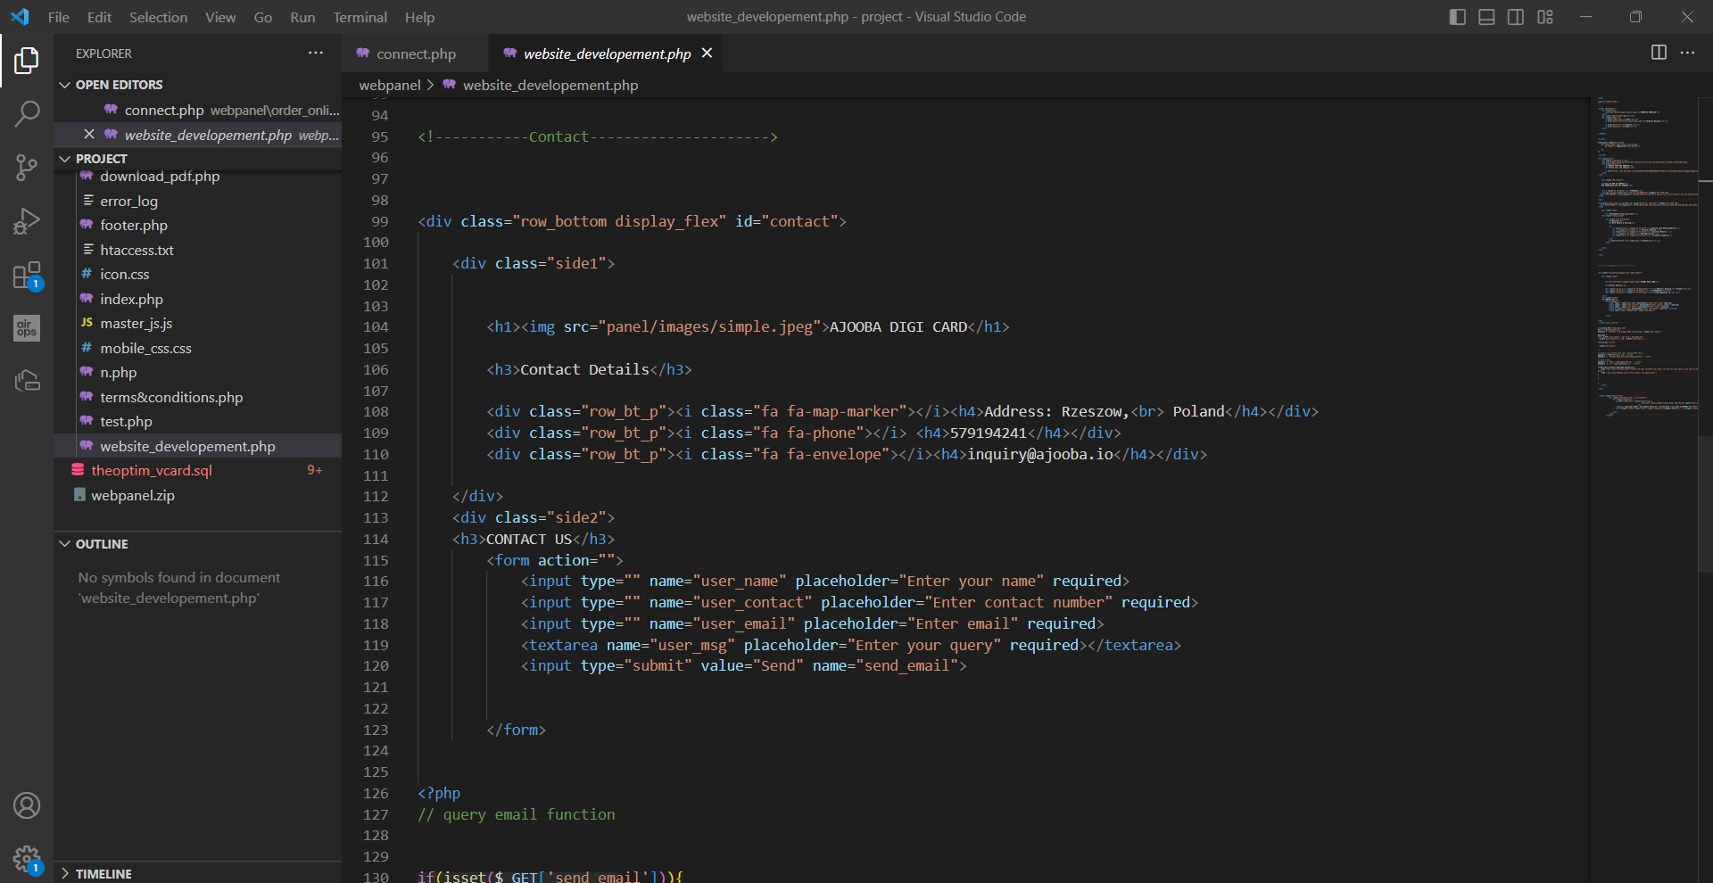

Fig. 32 Source Code of Website Development (2)

Source: Own Study

PHP Source code of the website development 3 page is the Source Code of Website Home page in this figure there is a code for Connection with Administrator. After Customer send a query to the Administrator there is an auto generated HTML text created by this code and if any information is not correct there is an error text created by this Code.

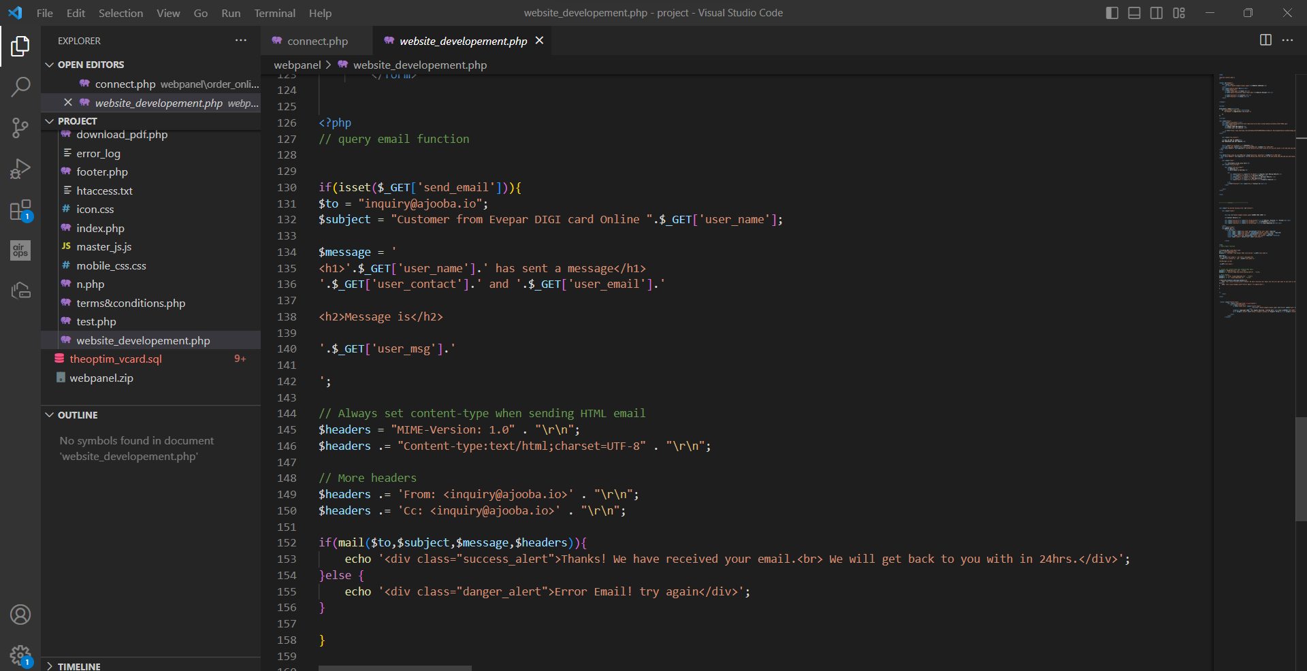

Fig. 33 PHP Source Code of Website Development (3)

Source: Own Study

PHP Source Code of Connection between Website is the Source Code of Website Connection page in this figure there is a code for main Connection from home page buttons with Customer login and creating the card.

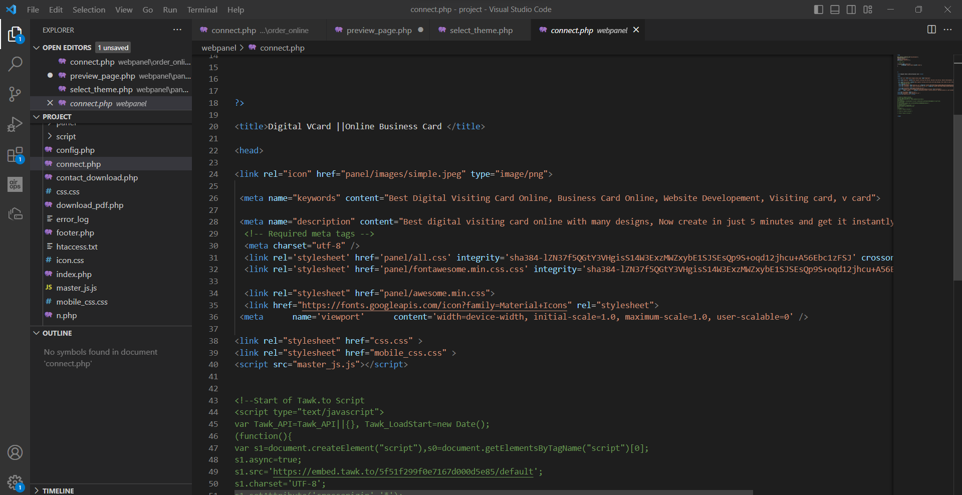

Fig. 34 PHP Source Code of Connection between Websites

Source: Own Study

### 3.4.2 PHP Source Code of Customer Login

PHP Source Code for Customer Login 1 is the Source Code of Customer Login page. In this figure there is a code for customer to input their Email and password for login. Or if customer do not have an account they can create an account with their Name, Phone Number, Email and New Password.

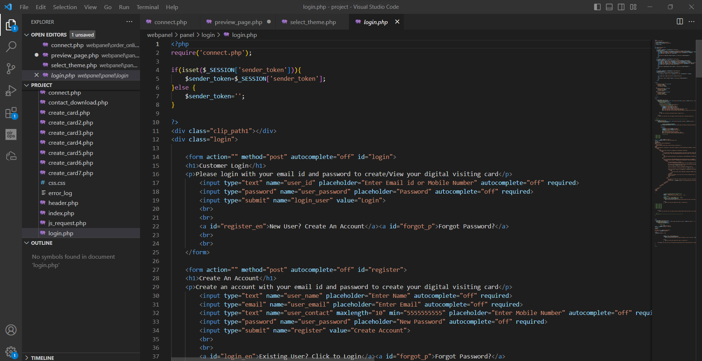

Fig. 35 PHP Source Code for Customer Login (1)

Source: Own Study

PHP Source Code for Customer Login 2 is the Source Code of Customer Login page. In this figure there is a code for customer to change password if they forget their Password with their Name, Phone Number, Email and New Password.

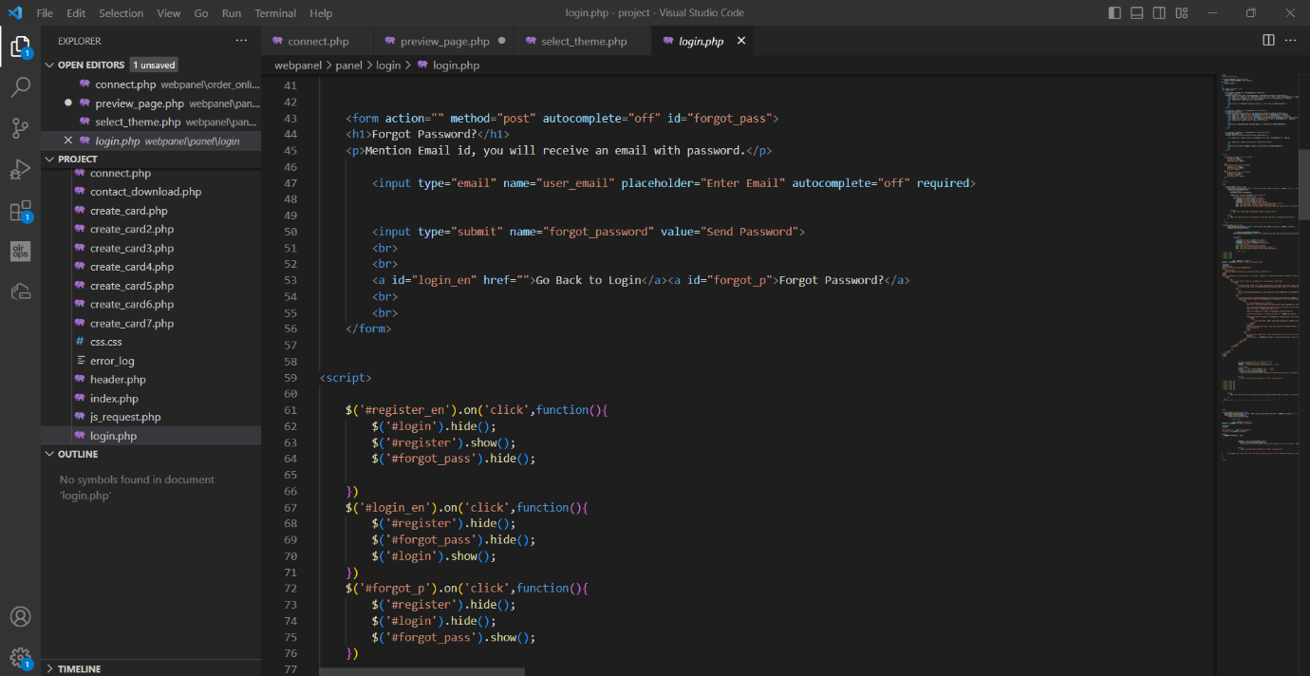

Fig. 36 PHP Source Code for Customer Login (2)

Source: Own Study

PHP Source Code for Customer Login 3 is the Source Code of Customer Login page. In this figure there is a code that will send an email with link to change password. And will send an email if Customer login information is not available and it is not possible to log that customer in.

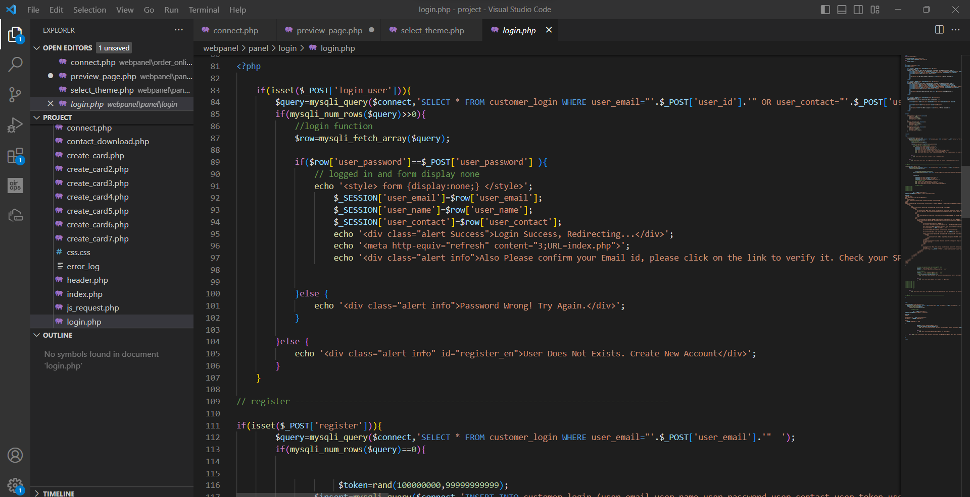

Fig. 37 PHP Source Code for Customer Login (3)

Source: Own Study

### 3.4.3 PHP Source Code of creating a Business Card

PHP Source Code for making a Business Card 1 is the Source Code of Process of making Business Card. In this figure there is a code that will check if Customer is logged in properly and start process of making a digital Card with input value.

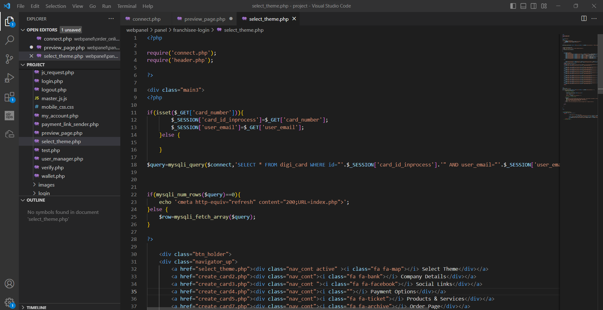

Fig. 38 PHP Source Code for making a Business Card (1)

Source: Own Study

PHP Source Code for making a Business Card 2 This is the Source Code of Process of making Business Card. In this figure there is a code that will check the input value like Theme, Company Details, Payment Details Etc, and create Card step by step.

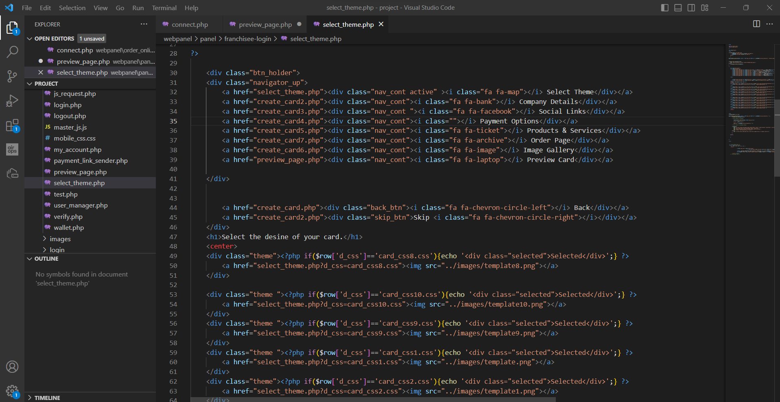

Fig. 39 PHP Source Code for making a Business Card (2)

Source: Own Study

PHP Source Code for making a Business Card 3 is the Source Code of Process of making Business Card. In this figure there is a code that will check if all the input data is correct or no. If it is not correct it will generate a text for Error.

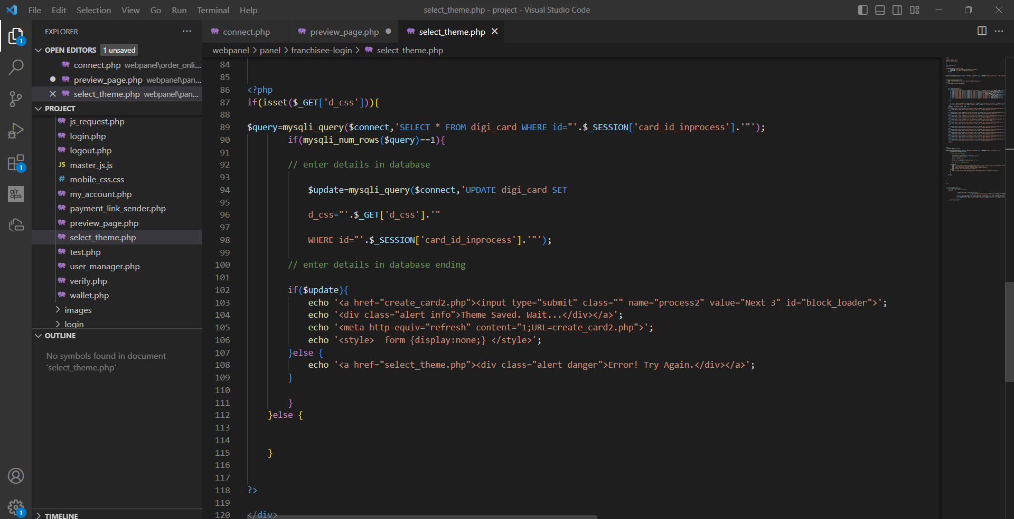

Fig. 40 PHP Source Code for making a Business Card (3)

Source: Own Study

### 3.4.4 PHP Source Code of Franchisee Login and Index

PHP Source Code for Franchisee Login 1 is the Source Code of Franchisee Login page. In this figure there is a code for Card Owner to input their Email and password for login. Or if they do not have an account they can create an account with their Name, Phone Number, Email and New Password.

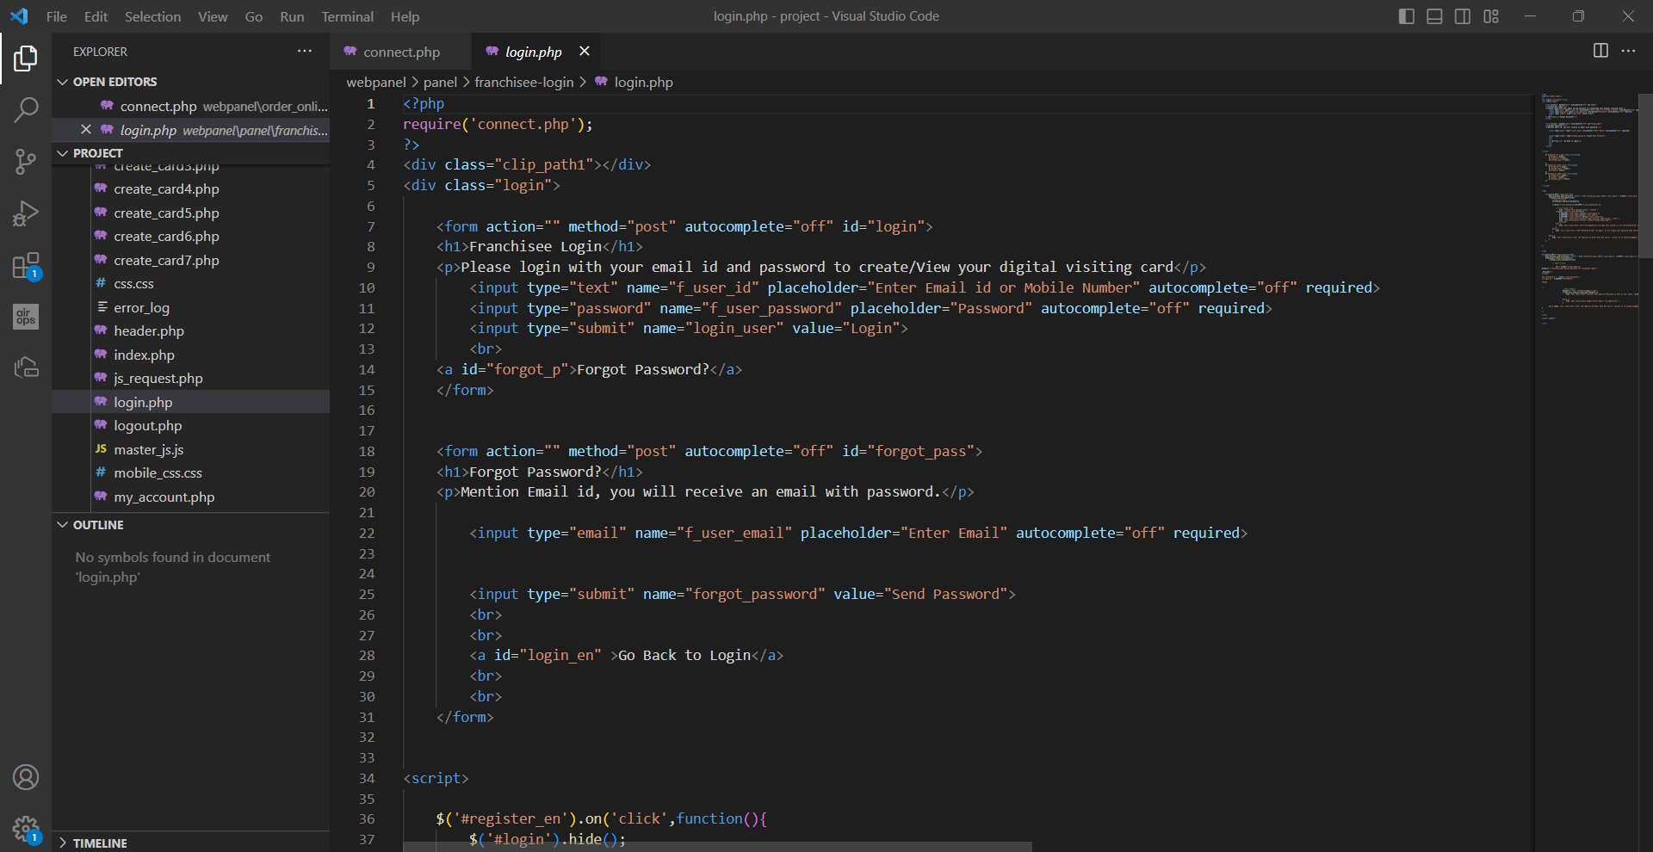

Fig. 41 PHP Source Code for Franchisee Login (1)

Source: Own Study

PHP Source Code for Franchisee Login 2 is the Source Code of Franchisee Login page. In this figure there is a code for Card Owner to change password if they forget their Password or their account is not active anymore with Contacting the Administrator’s Email.

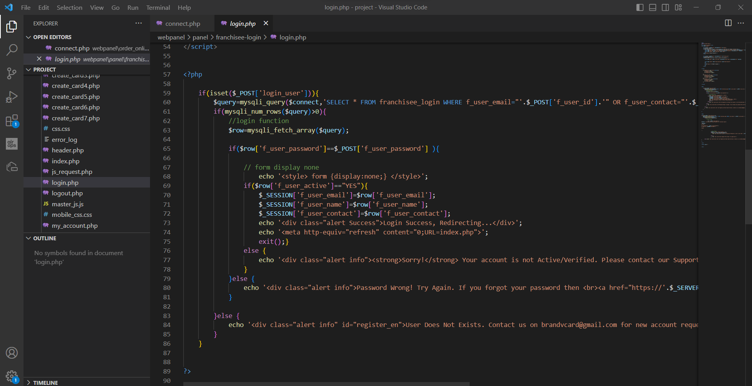

Fig. 42 PHP Source Code for Franchisee Login (2)

Source: Own Study

PHP Source Code for Franchisee Login 3 is the Source Code of Franchisee Login page. In this figure there is a code for Card Owner to change password if they forget their Password or their account is not active anymore with Contacting the Administrator’s Email with Error.

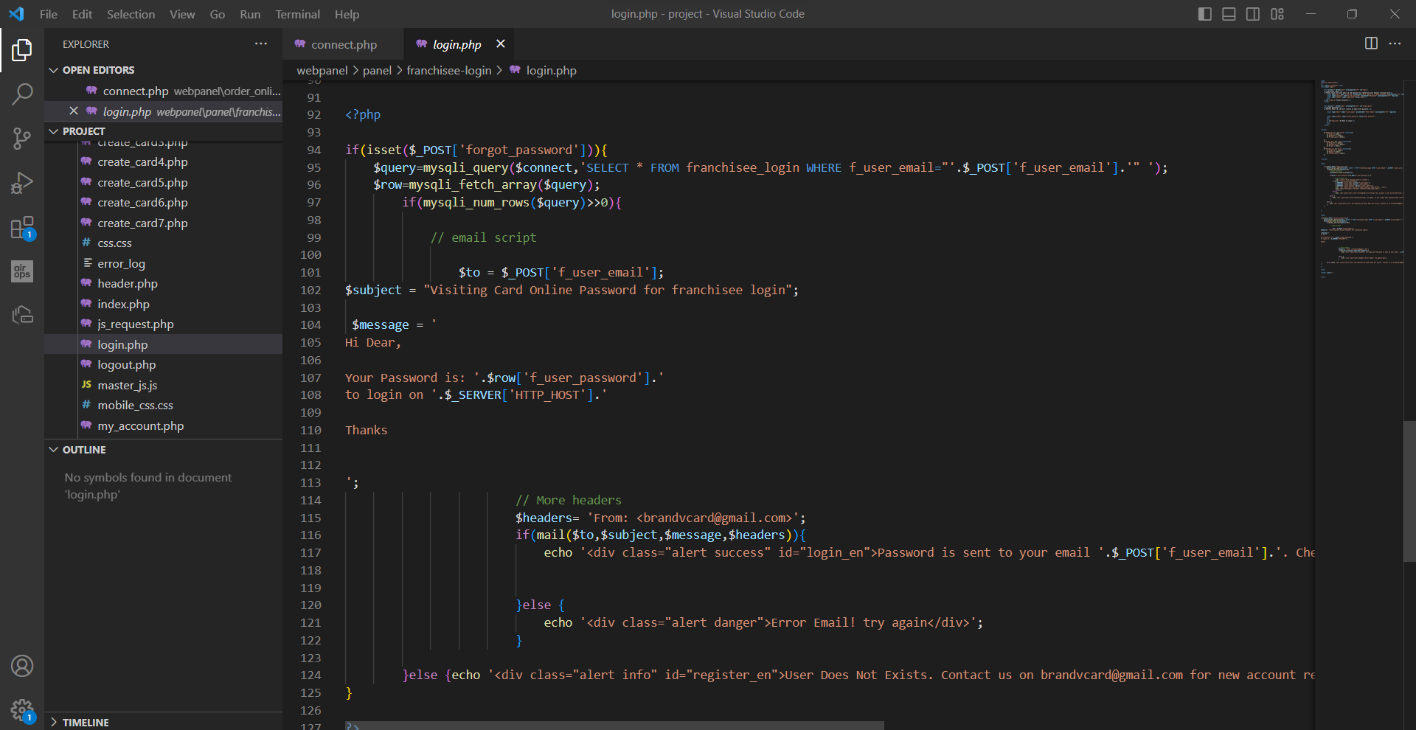

Fig. 43 PHP Source Code for Franchisee Login (3)

Source: Own Study

PHP Source Code for Franchisee index Page 1 is the Source Code of Franchisee Index page. In this figure there is a code for Card Owner to manage their account, cards, and users.

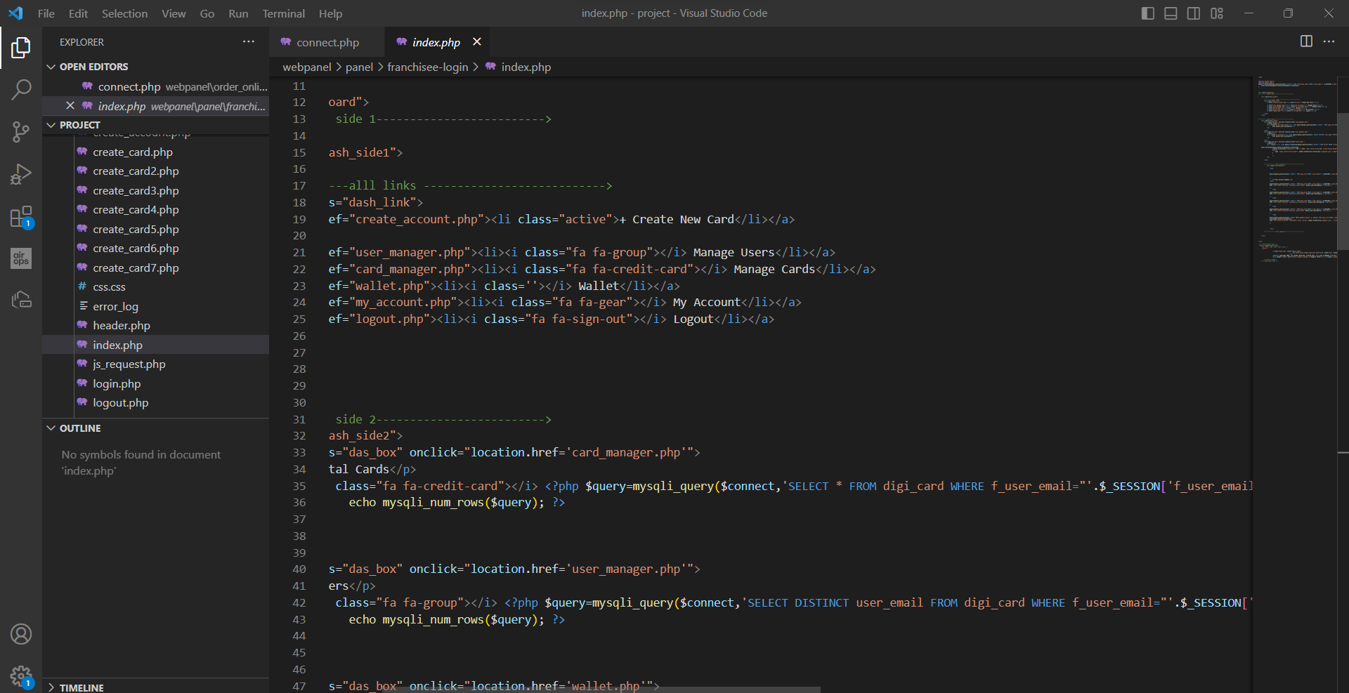

Fig. 44 PHP Source Code for Franchisee index Page (1)

Source: Own Study

PHP Source Code for Franchisee index Page 2 is the Source Code of Franchisee Index page. In this figure there is a code for Card Owner to see the details of the chart with number of users and number of cards there.

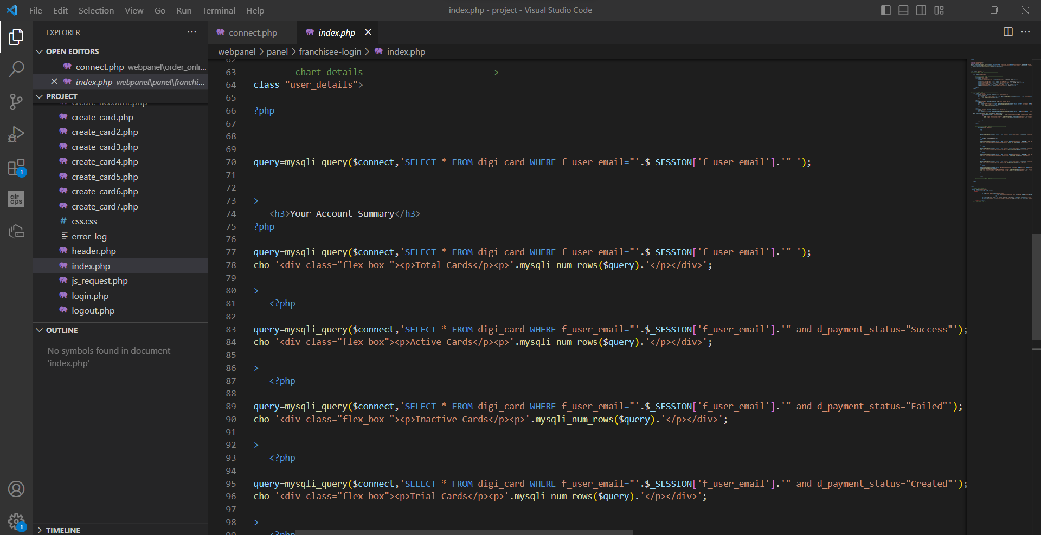

Fig. 45 PHP Source Code for Franchisee index Page (2)

Source: Own Study

### 3.4.5 PHP Source Code of User Management

PHP Source Code for User Management Page 1 is the Source Code of User Management Page. In this figure there is a code to see the cards and data of the user and if there is no user there is an auto generated text with no data available.

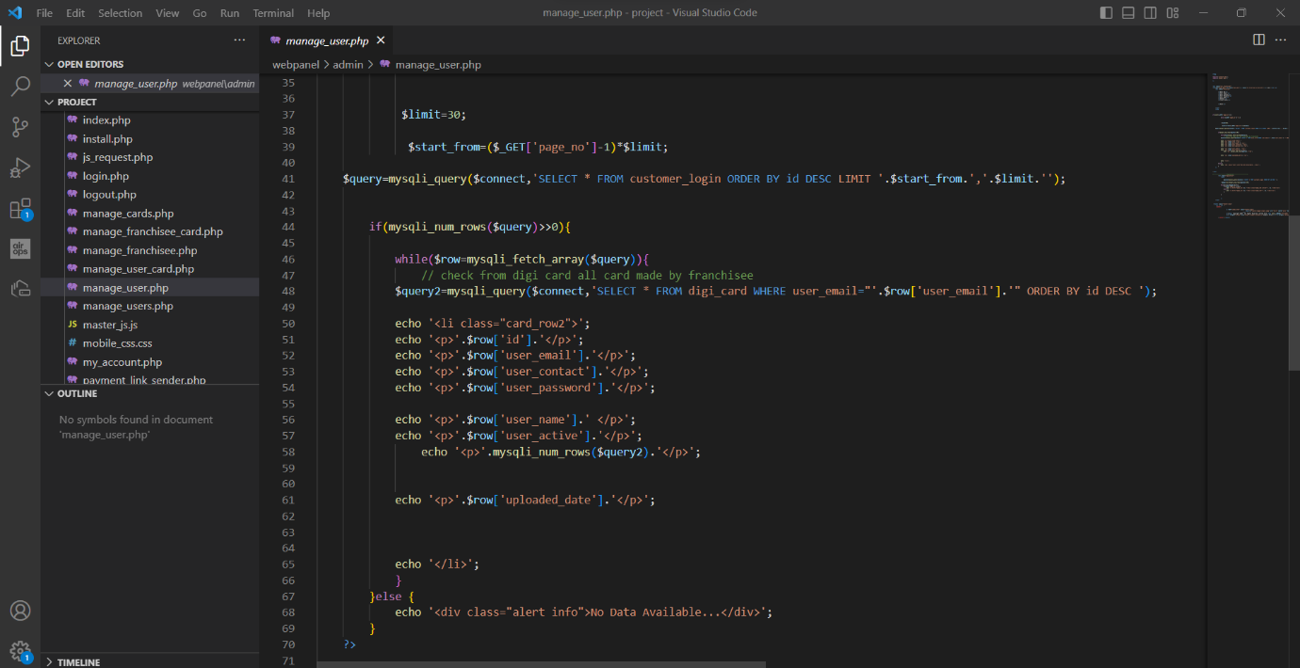

Fig. 46 PHP Source Code for User Management Page (1)

Source: Own Study

PHP Source Code for User Management Page 2 is the Source Code of User Management Page. In this figure there is a code to see the cards and data of the user. And HTML codes for Footer of the page with copyright act, Etc.

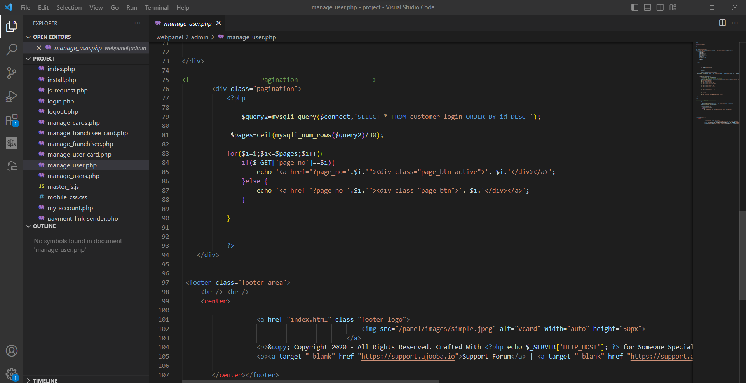

Fig. 47 PHP Source Code for User Management Page (2)

Source: Own Study

## 3.5 Implementation

In accordance with the design phase, the system is coded using PHP, JavaScript, HTML, CSS, and XAMPP with MySQL. Due to its server-side functionality, PHP was chosen as the back-end language, whilst JavaScript improves client-side interactivity. Web pages are structured using HTML and CSS, which are also used to apply styling. The database is set up using XAMPP, ensuring effective data storage and retrieval.

## 3.5.1 Justification of Software Tools Choice

Due to their widespread use, robust community support, and suitability for web development, PHP, JavaScript, HTML, CSS, and XAMPP with MySQL were chosen. Server-side scripting works well with PHP, which also provides a wide range of frameworks and modules for effective development. JavaScript is a powerful language that enables dynamic and interactive user interface elements. The foundation for organizing and styling web pages is provided by HTML and CSS. For local development environments, XAMPP with MySQL is a well-liked option because it provides a reliable relational database management system.

Used Front-end and Back-end technologies for building the Business Card maker applications include.

### 3.5.2 Front-end of the Website

1. HTML (Hypertext Markup Language)

HTML is the standard markup language used to structure the content of web pages. It provides the basic structure and elements for displaying information on the web.[7]

1. CSS (Cascading Style Sheets)

CSS is used to define the presentation and layout of HTML documents. It allows developers to control the appearance of the supermarket management system, including colors, fonts, spacing, and positioning of elements.

1. JavaScript

JavaScript is a widely used programming language that adds interactivity and dynamic functionality to web pages. It can be used to handle user input, validate forms, perform calculations, and communicate with the back-end server.[8]

### 3.5.3 Back-end of the Website

1. PHP (Hypertext Preprocessor)

PHP is a server-side scripting language used for web development. It integrates easily with HTML, supports multiple databases, and offers flexibility through frameworks. It executes on the server, allowing dynamic content generation. PHP is open source, has a supportive community, and is commonly used for building websites and web applications.

1. XAMPP

XAMPP is a cross-platform software package that provides a local web server environment for developers to create and test web applications on their own computers. It includes components such as Apache (web server), MySQL (database), PHP, and Perl, hence the name XAMPP (cross-platform, Apache, MySQL, PHP, Perl). XAMPP simplifies the setup process by bundling these components together, allowing developers to quickly install and configure a local web server for development purposes without the need for individual installations of each component.[9]

1. SQL Database

A SQL database is a structured collection of data stored in tables, with rows representing instances and columns defining attributes. It ensures data integrity, provides a standardized query language, supports scalability, and maintains ACID properties. Examples include MySQL, PostgreSQL, Oracle, SQL Server, and SQLite.

## 3.6 Testing:

The testing process is essential for ensuring the online business card generator's dependability, usability, and performance. It entails carrying out numerous tests, including user acceptance testing, integration testing, and unit testing. While integration testing analyzes the relationships between several modules, unit testing verifies that each part of the system operates correctly. Users are involved in user acceptability testing to assess the system's usability and generate suggestions for enhancements.

## 3.7 Recommendation for Deployment:

It is advised to select a reputable web hosting company for deployment who offers the required resources and infrastructure to support the online business card generator. To ensure smooth operation and defence against any threats, the hosting provider should offer sufficient storage, bandwidth, and security measures. The system must also be continuously updated and maintained in order to fix any security flaws while taking user feedback into account for ongoing improvement. Overall, building an online business card generator with PHP, JavaScript, HTML, CSS, XAMPP, and MySQL provides a strong foundation for building a user-friendly and effective solution.

By following a thorough requirements analysis, design, and implementation process, along with rigorous testing, the system can be deployed successfully, meeting the needs of professionals seeking to create personalized business cards conveniently and quickly.[10]

# **Conclusion**

In conclusion, an organized process is used in the creation of a blockchain-based academic system for storing student records. The Agile technique is used, enabling flexibility, adaptation, and the delivery for incremental value. The system is implemented using an object-oriented methodology, guaranteeing code reuse, scalability, and simpler maintenance.

The client-server web-oriented architecture that was adopted offers simple maintenance, centralized data administration, and easy accessibility through web browsers. For better code organization and maintainability, the Model-View-Controller (MVC) software architecture is used, which separates data, display, and user interaction. A single-page application (SPA) was used in the system's design to provide a seamless user experience with few page reloads.[11]

The user interface design follows current web design guidelines and includes responsive design for device adaptability, simple navigation, and aesthetically pleasing elements. These features improve system engagement and user happiness.

The efficiency and reliability of the system are guaranteed by a thorough software testing strategy that incorporates both manual and automated methodologies. While automated testing uses frameworks like PHPUnit and Selenium to carry out regression, unit, and integration tests, manual testing focuses on test scenarios and user acceptability testing.[12]

Overall, the academic system built on blockchain provides academic institutions with a secure and efficient platform for managing student records. The system complies with academic institution criteria and promotes academic process transparency by using a systematic development process, suitable methodologies, software architectures, UI design techniques, and testing procedures.

# **Literature**

1. [The importance of a complete online presence for businesses (openaccessgovernment.org)](https://www.openaccessgovernment.org/the-importance-of-a-complete-online-presence-for-businesses/115920/) (Accessed on 22.05.2023)
2. [4 features of a fully functional website - Flicker Leap](https://flickerleap.com/4-features-of-a-fully-functional-website/) (Accessed on 22.05.2023)
3. [Introduction to HTML (w3schools.com)](https://www.w3schools.com/html/html_intro.asp) (Accessed on 5.05.2023)
4. [What is JavaScript? | Codecademy](https://www.codecademy.com/article/what-is-javascript) (Accessed on 5.05.2023)
5. [XAMPP - Wikipedia](https://en.wikipedia.org/wiki/XAMPP) (Accessed on 6.05.2023)
6. [How agile software development methods reduce work exhaustion: Insights on role perceptions and organizational skills - Venkatesh - 2020 - Information Systems Journal - Wiley Online Library](https://onlinelibrary.wiley.com/doi/10.1111/isj.12282) (Accessed on 10.06.2023)
7. [The 5 Stages of the Agile Software Development Lifecycle (mendix.com)](https://www.mendix.com/blog/agile-software-development-lifecycle-stages/) (Accessed on 10.06.2023)
8. [Common web application architectures | Microsoft Learn](https://learn.microsoft.com/en-us/dotnet/architecture/modern-web-apps-azure/common-web-application-architectures) (Accessed on 5.06.2023)
9. [Responsive design - Learn web development | MDN (mozilla.org)](https://developer.mozilla.org/en-US/docs/Learn/CSS/CSS_layout/Responsive_Design) (Accessed on 6.06.2023)
10. <http://eprints.zu.edu.ua/22188/1/113.pdf> (Accessed on 7.06.2023)
11. [Ch.8 - User Interface Design (Phase 3 of SDLC) Flashcards | Quizlet](https://quizlet.com/547235799/ch8-user-interface-design-phase-3-of-sdlc-flash-cards/) (Accessed on 20.06.2023)
12. [What Is Requirements Analysis? Process and Techniques | Indeed.com](https://www.indeed.com/career-advice/career-development/requirements-analysis) (Accessed on 17.06.2023)

[Model–view–controller - Wikipedia](https://en.wikipedia.org/wiki/Model%E2%80%93view%E2%80%93controller) (Accessed on 22.06.2023)

[System Reliability Management: Solutions and Technologies (colostate.edu)](https://www.cs.colostate.edu/~malaiya/p/SoftwareReliability.Chapter13.18.pdf) (Accessed on 23.06.2023)

[Learn how to build a website using HTML, CSS, PHP, & MySQL | by Sapph Dek | Medium](https://medium.com/@sapphdek/learn-how-to-build-a-website-using-html-css-php-mysql-af385524a5d6) (Accessed on 23.06.2023)

[PHP Tutorial (w3schools.com)](https://www.w3schools.com/php/) (Accessed on 25.06.2023)

[How to Make a Website from Scratch Using PHP and MYSQL (yonkov.github.io)](https://yonkov.github.io/post/how-to-make-a-website-from-scratch-using-php-and-mysql/) (Accessed on 25.06.2023)

[HTML CSS Javascript PHP MySQL To Build A Website (Simple Example) (code-boxx.com)](https://code-boxx.com/use-html-css-javascript-php-mysql/) (Accessed on 25.06.2023)

# 6. Summary

**Diploma Thesis Summary**

Blockchain system for academia system

**Author:** Jash Vaidya

**Supervisor:** Dr Kateryna Yalova

**Key words:** Diploma thesis focuses on developing an online business card generator using HTML, CSS, JavaScript, PHP, and MySQL.

The business card generator project provides a user-friendly online solution for creating customized business cards. By leveraging technologies such as XAMPP, MySQL, HTML, CSS, PHP, and JavaScript, the project aims to streamline the process while storing client information. It enhances marketing efforts and offers a comprehensive tool for professionals in various domains.

# List Of Figures

Figure 1 Home page 7

Figure 2 About Us Page 8

Figure 3 How it works Page 8

Figure 4 Template Selection Page 1 9

Figure 5 Template Selection Page 2 10

Figure 6 Services We Offer Page 10

Figure 7 Features Page 11

Figure 8 Contact Us Page 11

Figure 9 Customer Log in Page. 12

Figure 10 Dashboard of Customer Page. 12

Figure 11 Input Page for Business or Company Name. 13

Figure 12 Template selection Page. 13

Figure 13 Company Details Page. 14

Figure 14 Social links Page. 14

Figure 15 Payment links Page. 15

Figure 16 Product or Services Page. 15

Figure 17 Ecommerce Page. 16

Figure 18 Image Gallery Page. 16

Figure 19 Preview of Business Card Page1. 17

Figure 20 Preview of Business Card Page2. 17

Figure 21 Preview of Business Card Page3. 18

Figure 22 Franchisee Login Page. 18

Figure 23 Dashboard of Franchisee Login. 19

Figure 24 Add Money Page. 19

Figure 25 Franchisee Profile Page. 20

Figure 26 SQL Database Main Page. 20

Figure 27 SQL Database Admin Login Table. 21

Figure 28 Database Customer Login Table. 21

Figure 29 SQL Database Franchisee Login Table. 22

Figure 30 Database Wallet Table. 22

Figure 31 PHP Source Code of Website Development (1). 23

Figure 32 Source Code of Website Development (2). 23

Figure 33 PHP Source Code of Website Development (3). 24

Figure 34 PHP Source Code of Connection between Website. 24

Figure 35 PHP Source Code for Customer Login (1). 25

Figure 36 PHP Source Code for Customer Login (2). 25

Figure 37 PHP Source Code for Customer Login (3). 26

Figure 38 PHP Source Code for making a Business Card (1). 26

Figure 39 PHP Source Code for making a Business Card (2). 27

Figure 40 PHP Source Code for making a Business Card (3). 27

Figure 41 PHP Source Code for Franchisee Login (1). 28

Figure 42 PHP Source Code for Franchisee Login (2). 28

Figure 43 PHP Source Code for Franchisee Login (3). 29

Figure 44 PHP Source Code for Franchisee index Page (1). 29

Figure 45 PHP Source Code for Franchisee index Page (2). 30

Figure 46 PHP Source Code for User Management Page (1). 30

Figure 47 PHP Source Code for User Management Page (1). 31

1. [How agile software development methods reduce work exhaustion: Insights on role perceptions and organizational skills - Venkatesh - 2020 - Information Systems Journal - Wiley Online Library](https://onlinelibrary.wiley.com/doi/10.1111/isj.12282) (Accessed on 10.06.2023)
2. [The 5 Stages of the Agile Software Development Lifecycle (mendix.com)](https://www.mendix.com/blog/agile-software-development-lifecycle-stages/) (Accessed on 10.06.2023)
3. [Common web application architectures | Microsoft Learn](https://learn.microsoft.com/en-us/dotnet/architecture/modern-web-apps-azure/common-web-application-architectures) (Accessed on 5.06.2023)
4. [Responsive design - Learn web development | MDN (mozilla.org)](https://developer.mozilla.org/en-US/docs/Learn/CSS/CSS_layout/Responsive_Design) (Accessed on 6.06.2023)
5. <http://eprints.zu.edu.ua/22188/1/113.pdf> (Accessed on 7.06.2023)
6. [Ch.8 - User Interface Design (Phase 3 of SDLC) Flashcards | Quizlet](https://quizlet.com/547235799/ch8-user-interface-design-phase-3-of-sdlc-flash-cards/) (Accessed on 20.06.2023)
7. [Introduction to HTML (w3schools.com)](https://www.w3schools.com/html/html_intro.asp) (Accessed on 5.05.2023)
8. [What is JavaScript? | Codecademy](https://www.codecademy.com/article/what-is-javascript) (Accessed on 5.05.2023)
9. [XAMPP - Wikipedia](https://en.wikipedia.org/wiki/XAMPP) (Accessed on 6.05.2023)
10. [What Is Requirements Analysis? Process and Techniques | Indeed.com](https://www.indeed.com/career-advice/career-development/requirements-analysis) (Accessed on 17.06.2023)
11. [Model–view–controller - Wikipedia](https://en.wikipedia.org/wiki/Model%E2%80%93view%E2%80%93controller) (Accessed on 22.06.2023)
12. [System Reliability Management: Solutions and Technologies (colostate.edu)](https://www.cs.colostate.edu/~malaiya/p/SoftwareReliability.Chapter13.18.pdf) (Accessed on 23.06.2023)